  - SOP 42 | Advanced administration

Use tracking safety and emergency controls
Record an authorized effective-dated property tracking control.
For Web and mobile · Administrator / Supervisor
Before you start Verify the exact property and operational reason. These controls affect tracking authorization.
Open Account > Tracking safety & emergency stops

Step 1 Select the property
Open Tracking safety or Remote tracking control and verify the property header.

Step 2 Choose the control
Select the intended enable/disable state. Read the effective start and optional end fields; web control times are explicitly UTC.

Step 3 Record the reason and save
Enter Operational reason and use Record tracking control. Verify the saved history and effective interval.

Step 4 Follow up on device state
Devices stop when they receive the control. Check the affected run and contact the worker if a phone remains offline or local stop needs attention.
Check your result Control history shows the intended version and interval; the server rejects post-cutoff collection.
If something goes wrong An offline phone may not receive a remote instruction immediately. Re-enabling tracking does not bypass assignments, policy or a session cutoff.
See the picture reference on the next page.

SOP 42 Picture reference
  - Use tracking safety and emergency controls
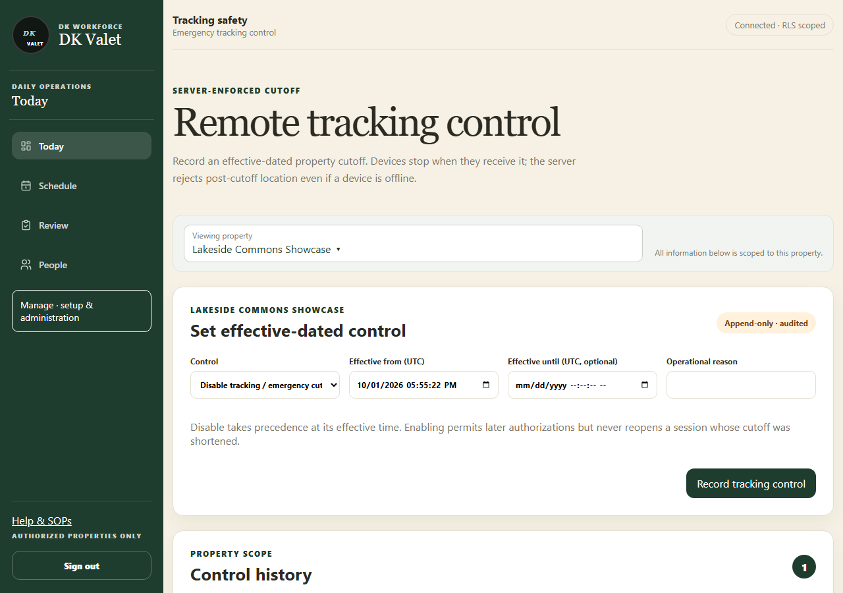
Step 2 · Remote tracking control: use the property selector and the task controls shown.
Application screenshot with training data.

