DK Valet Workforce user handbook
  - Property setup scheduling and daily work
Use these 55 procedures to find the right screen, complete a task and check its result. Each procedure contains numbered instructions and a picture reference. The same procedures are available under Help and SOPs in the application.

Choose your starting point
New associates Start with SOPs 01–03, then 32–41 for planning, arrival, route work and closeout.
Supervisors Use SOPs 13–21 for scheduling and daily review, and 22–27 for setup walks and route publication.
Administrators Start property onboarding with 04–11. Use 28–31 and 42–52 for the advanced controls your role permits.

Set up a property in order
Create the property → approve its boundary → assign eligible people → set weekly service windows → complete a setup walk → review units → publish a master → publish the associate route → verify readiness → assign dated shifts.

Use each procedure
Read Before you start and Open first. Follow Steps 1, 2, 3 and any remaining steps, then check the result. Use the picture reference for the named step. Controls vary by role, property configuration and device.
Always confirm the property and displayed time zone. Keep unknown or degraded evidence visible. Phone location and inferred route lines do not prove an exact indoor unit or floor. Confirm that collection has stopped and that uploads have completed as separate checks.
Pictures contain training examples. Screenshots, component previews and workflow illustrations are labeled. This handbook describes the application as reviewed on 2026-10-12.

Procedure index
01 Activate your account and sign in
Web and mobile · Page 6
02 Reset a password and unlock the app
Web and mobile · Page 8
03 Find your workspace and the correct property
Web and mobile · Page 10
04 Create a property
Web · Page 12
05 Review the address and save a work boundary
Web and mobile · Page 14
06 Complete property readiness
Web and mobile · Page 16
07 Set weekly service times and staffing defaults
Web and mobile · Page 18
08 Maintain standing start instructions
Web and mobile · Page 20
09 Invite a person to the workforce app
Web and mobile · Page 22
10 Maintain people and property access
Web and mobile · Page 24
11 Record property access and training eligibility
Web and mobile · Page 26
12 Use account security controls
Web and mobile · Page 28
13 Read the staffing calendar
Web and mobile · Page 30
14 Assign people to a service window
Web and mobile · Page 32
15 Create edit or cancel a dated shift
Web and mobile · Page 34
16 Review a time off request
Web and mobile · Page 36
17 Request coverage and assign a replacement
Web and mobile · Page 38
18 Monitor daily and district operations
Web and mobile · Page 40

Procedure index continued
19 Record a handoff and review an exception
Web and mobile · Page 42
20 Find and inspect a completed run
Web and mobile · Page 44
21 Replay compare and export run evidence
Web and mobile · Page 46
22 Start a mobile property setup walk
Mobile · Page 48
23 Mark units and add optional setup photos
Mobile · Page 50
24 Finish recover and upload a setup walk
Mobile · Page 52
25 Review setup walks and unit records
Web and mobile · Page 54
26 Review and publish the master reference
Web · Page 56
27 Publish the associate route
Web · Page 58
28 Maintain checkpoint definitions
Web · Page 60
29 Publish phase guidance and change a shift phase
Web · Page 62
30 Publish run requirements and review closeout exceptions
Web · Page 64
31 Configure run questions
Web and mobile · Page 66
32 Use My work and Account and help
Mobile · Page 68
33 View your calendar and accept or decline shifts
Mobile · Page 70
34 Read work updates and reply to coverage opportunities
Mobile · Page 72
35 Set recurring weekly availability and review extra hours
Mobile · Page 74
36 Request or cancel time off
Mobile · Page 76

Procedure index continued
37 Prepare for a shift and clock in
Mobile · Page 78
38 Answer run questions and add photos
Mobile · Page 80
39 Follow the route and report an issue
Mobile · Page 82
40 Finish a route and confirm clock out
Mobile · Page 84
41 Recover from offline or tracking problems
Mobile · Page 86
42 Use tracking safety and emergency controls
Web and mobile · Page 88
43 Inspect processing health and retry a failed job
Web and mobile · Page 90
44 Manage approved data collection and timing policies
Web · Page 91
45 Read device and tracking insights
Web · Page 93
46 Use the setup research workbench
Web · Page 95
47 Perform an authorized guided movement test
Mobile · Page 97
48 Find missing setup history and request an archive review
Web and mobile · Page 99
49 Sign out and review privacy information
Web and mobile · Page 101
50 Build copy or bulk edit shifts
Web · Page 103
51 Set an effective staffing target
Web · Page 105
52 Export the operations view
Web · Page 107
53 Publish property and global notes
Web and mobile · Page 108
54 Configure building and floor numbering
Web and mobile · Page 110

Procedure index continued
55 Start a supervisor support run
Mobile · Page 112

  - SOP 01 | Getting started

Activate your account and sign in
Activate the account provided by your manager and open your assigned work.
For Web and mobile · Administrator / Supervisor / Associate
Before you start Use your own invitation and the approved DK Valet Workforce installation.
Open Invitation email or Sign in

Step 1 Open your invitation
Open the activation link in the invitation email. Follow the password setup screen. If the link has expired or was cancelled, contact the person who invited you.

Step 2 Set your permanent password
Enter and confirm the password requested on screen. If you were issued a temporary password, complete the required permanent password change before opening work.

Step 3 Sign in
Open the Operations website or installed mobile app. Enter your work email and password, then select Sign in. Complete device unlock if prompted.

Step 4 Check your workspace
Associates use My work. Managers and supervisors use their available management workspace. Confirm the property before taking any action.
Check your result Your assigned workspace opens and your authorized properties are available.
If something goes wrong Missing properties need an access review by an administrator. Creating a second account will not fix access.
See the picture reference on the next page.

SOP 01 Picture reference
  - Activate your account and sign in
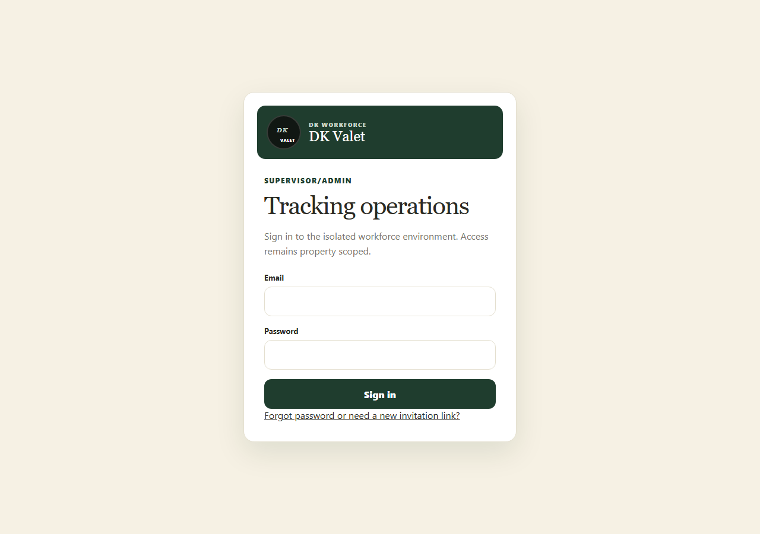
Step 3 · Sign in to the Operations website using your workforce account.
Application screenshot with training data.

  - SOP 02 | Getting started

Reset a password and unlock the app
Recover access to your existing account.
For Web and mobile · Administrator / Supervisor / Associate
Before you start Have access to the email address on your workforce account.
Open Sign in > Forgot password or Reset password

Step 1 Request a reset
On the website select Forgot password. On mobile enter your email and select Reset password.

Step 2 Open the latest email
Use the latest password reset link and follow the confirmation screen. Keep the link private.

Step 3 Save a new password
Complete the password and confirmation fields, submit, then return to sign in.

Step 4 Unlock an existing session
If mobile shows Session locked, select Use device unlock. Use another account signs out and returns to account entry.
Check your result You can sign in with the new password or unlock your existing session.
If something goes wrong If a link is invalid, request a fresh one. If delivery or account status still prevents access, contact your supervisor.
See the picture reference on the next page.

SOP 02 Picture reference
  - Reset a password and unlock the app
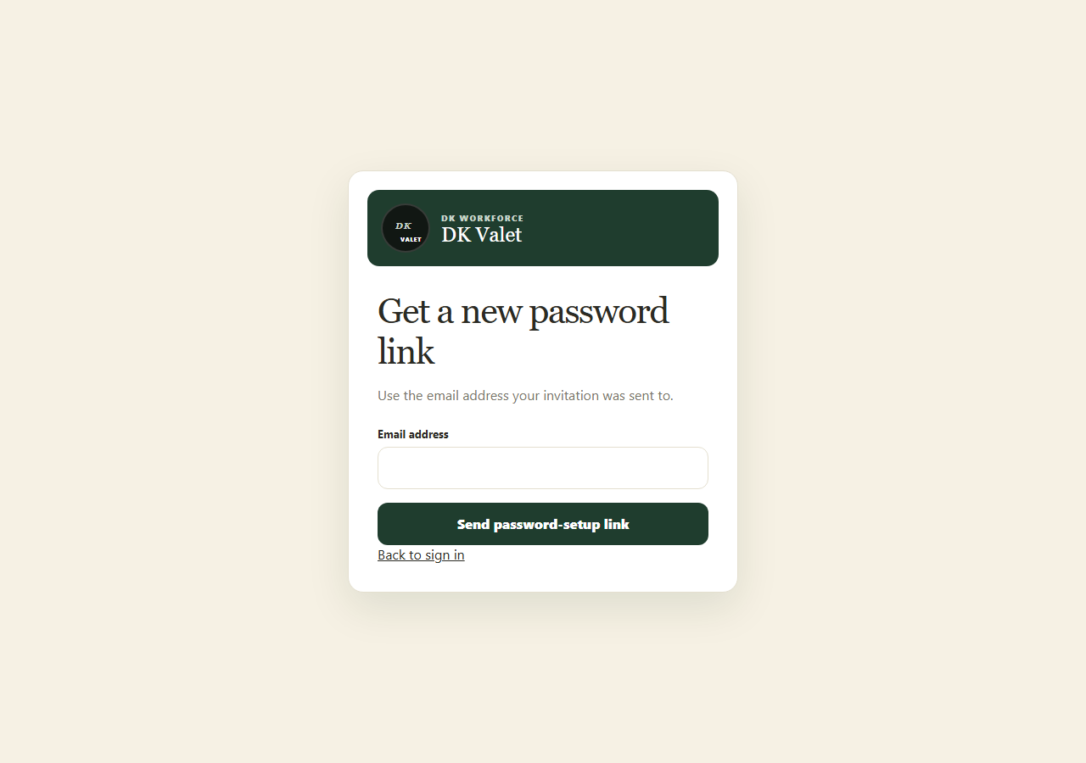
Step 1 · Request an email to recover your existing workforce account.
Application screenshot with training data.

  - SOP 03 | Getting started

Find your workspace and the correct property
Choose the correct task and property before reading or changing information.
For Web and mobile · Administrator / Supervisor / Associate
Before you start Your account must have active access to the property.
Open Operations or My work

Step 1 Choose daily work
On web use Today, Schedule, Review and People. On mobile managers use the daily workspace tabs; associates start at My work.

Step 2 Open management when needed
Use Manage for setup and administration. On mobile, open Company run questions for company scope, or choose a property then Run questions. Return with the displayed Back action; check unsaved-draft warnings.

Step 3 Select and verify the property
Use the property selector or Find property search. Read the property name on the destination and its displayed time zone.

Step 4 Use the task navigation
Use the screen Back or Home action to leave a task. Page through lists when more results exist. Clear filters if the list appears empty.
Check your result The screen header and selected property match the work you intend to perform.
If something goes wrong An empty authorized-property list is an access issue. Ask an administrator to review your assignment.
See the picture reference on the next page.

SOP 03 Picture reference
  - Find your workspace and the correct property
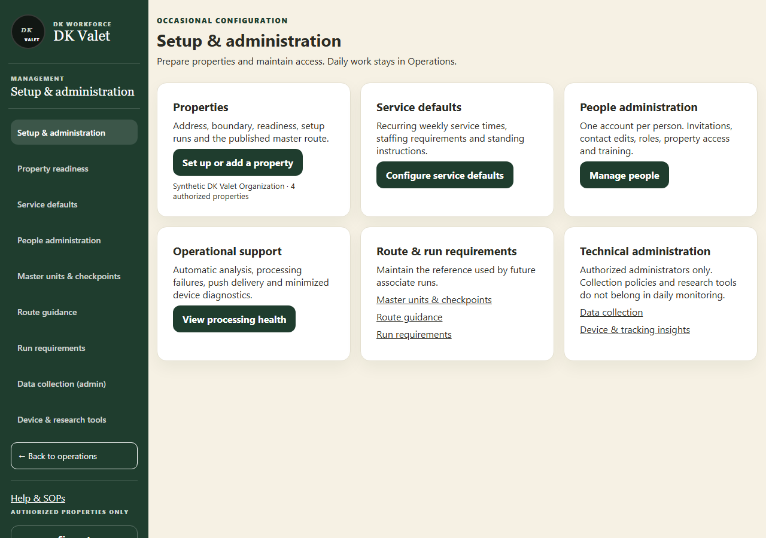
Step 2 · Setup & administration: use the property selector and the task controls shown.
Application screenshot with training data.

  - SOP 04 | Property setup

Create a property
Create the property record that the rest of setup uses.
For Web · Administrator
Before you start Have the approved property name, postal address and time zone. Organization-level creation access is required.
Open Manage > Set up or add a property

Step 1 Open property setup
Select Manage, then Set up or add a property. Locate Create address-only property.

Step 2 Enter the property identity
Choose the organization, enter Property name and verify Time zone. The default time zone may not be correct for this property.

Step 3 Choose and check the address
Use the address search and select the matching address. Review the structured address fields and correct them before submission.

Step 4 Create and select the property
Select Create address-only property and wait for the success message. Select the new property to continue its readiness steps.
Check your result The property appears in the authorized selector with its saved name and address.
If something goes wrong If creation is unavailable, ask an organization administrator. An address-only property still needs boundary, eligible people, weekly times and a published unit route.
See the picture reference on the next page.

SOP 04 Picture reference
  - Create a property
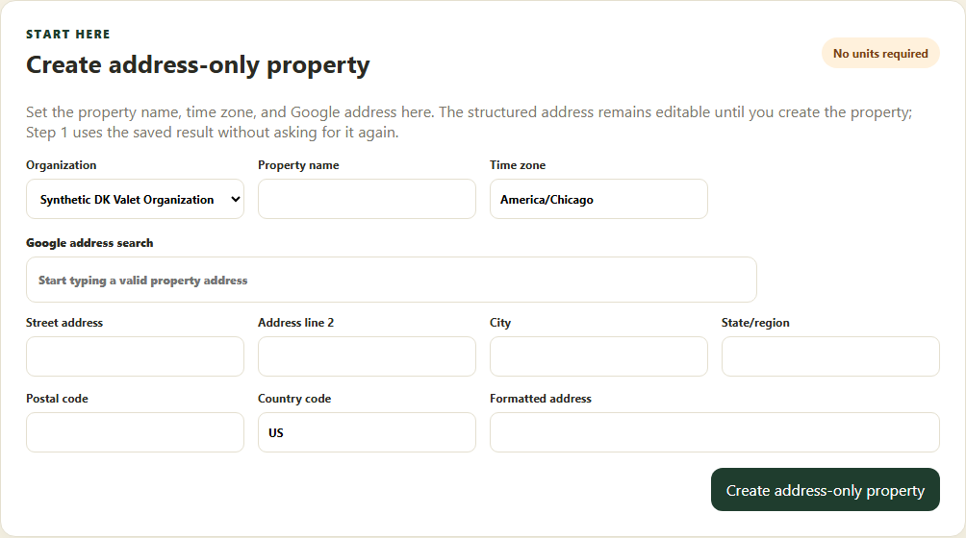
Step 3 · Enter the property identity and review the structured address before creating it.
Application screenshot with training data.

  - SOP 05 | Property setup

Review the address and save a work boundary
Define the reviewed outdoor boundary used by start checks.
For Web and mobile · Administrator / Supervisor
Before you start Create the property first and verify its address. Only users with boundary editing permission can save.
Open Manage > Property readiness > Review address and draw work boundary

Step 1 Open the property boundary
Select the property, then open Review address and draw work boundary. On mobile open the property readiness boundary task.

Step 2 Inspect the map
Locate the actual property and safe entrances. Verify the saved address and current boundary before drawing.

Step 3 Adjust the boundary
Use the available map boundary controls. For a polygon, place and review its corners around the property. Use the editor instructions to adjust or clear a draft.

Step 4 Review and save
Check the complete outline and any required review fields. Use the boundary save action, wait for confirmation and verify that an active boundary version is displayed.
Check your result Property readiness marks the boundary configured and the map shows the reviewed outline.
If something goes wrong A missing or inaccurate GPS position requires a fresh location check. Expanding a boundary to conceal a bad position is not a remedy.
See the picture reference on the next page.

SOP 05 Picture reference
  - Review the address and save a work boundary
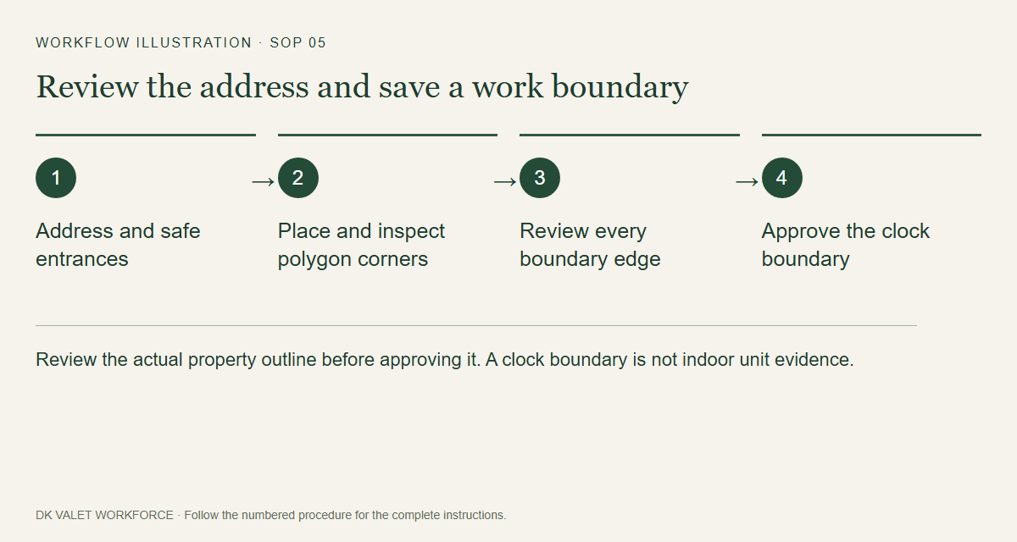
Step 2 · Review the actual property outline before approving it. A clock boundary is not indoor unit evidence.
Workflow illustration. Follow the complete numbered instructions on the previous page.

  - SOP 06 | Property setup

Complete property readiness
Check all requirements before assigning operational work.
For Web and mobile · Administrator / Supervisor
Before you start The property must already exist.
Open Manage > Property readiness

Step 1 Open the readiness checklist
Choose the property and read Ready for operations. Open each incomplete required step.

Step 2 Complete the first three requirements
Save a reviewed boundary, add at least one eligible worker and save weekly service times with staffing requirements.

Step 3 Complete the unit route
Perform the mobile setup walk, review its unit marks, publish a master reference and explicitly publish the associate route.

Step 4 Review instructions and run questions
Add useful start instructions and review Run questions for clock-in and clock-out. Use SOP 31 to configure company and property questions. Return to readiness and verify all four required steps.
Check your result Ready for operations is displayed for the selected property.
If something goes wrong Readiness does not itself clock anyone in. Device, assignment, training, policy and current start checks still apply.
See the picture reference on the next page.

SOP 06 Picture reference
  - Complete property readiness
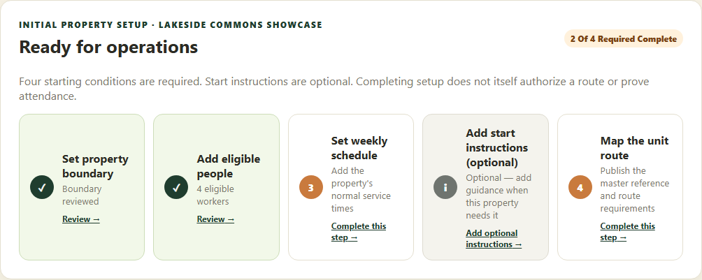
Step 1 · Complete the four required readiness items for the selected property.
Application screenshot with training data.

  - SOP 07 | Scheduling

Set weekly service times and staffing defaults
Set the recurring service windows that scheduling uses.
For Web and mobile · Administrator / Supervisor
Before you start Know the property-local workdays, start and end times, and people needed.
Open Manage > Service defaults

Step 1 Choose the property
Open Service defaults on web, or Manage then the property and Weekly service times on mobile. Verify the property time zone.

Step 2 Set the common time
Set start and end once for the selected service days. New templates default to 8 PM through 10 PM; existing saved times are preserved.

Step 3 Choose days and headcount
Select the weekdays requiring service and enter People needed. Use Different times by day or extra windows for exceptions rather than overwriting them.

Step 4 Review and publish
Review every selected day, overnight end time and headcount. Enter the required reason, then save or publish the week. Check the resulting version.

Step 5 Assign dated shifts
Open Schedule to assign people. Property-local start and end times appear beside property names. Saving defaults does not assign or accept a shift.
Check your result The saved weekly service windows and required headcount appear in the staffing calendar.
If something goes wrong If a day has no service time, add one before staffing it. Check the property time zone and date when a window appears on an unexpected day.
See the picture reference on the next page.

SOP 07 Picture reference
  - Set weekly service times and staffing defaults
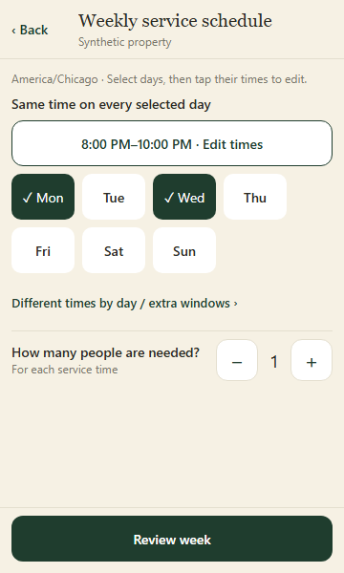
Step 3 · Choose service days, then set one common start and end time and the people needed.
Application component preview with training data. Native permission prompts may differ.

  - SOP 08 | Property setup

Maintain standing start instructions
Give setup participants and associates the information they need before starting.
For Web and mobile · Administrator / Supervisor
Before you start Prepare short, property-specific instructions. Do not put access codes or private credentials in notes.
Open Manage > Service defaults > Standing instructions

Step 1 Open the instructions
Select the property in Service defaults, then find Standing instructions. On mobile open Standing instructions for that property.

Step 2 Write the two messages
Use Before property setup for setup participants and Before an associate route for workers. Leave a message empty when no special instruction is needed.

Step 3 Review the message style
Use the warning option only when the information changes what the person should do. Check names, entrances and current hazards.

Step 4 Save and verify
Enter the reason and select Save start notes. Verify the saved text and version. Associates review the applicable message during route preparation.
Check your result The property displays the saved start notes.
If something goes wrong A saved note does not replace direct escalation for an immediate safety issue.
See the picture reference on the next page.

SOP 08 Picture reference
  - Maintain standing start instructions
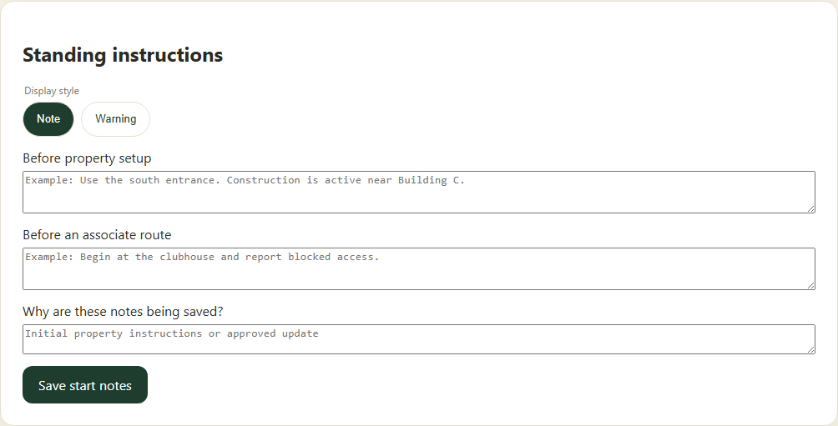
Step 2 · Separate setup instructions from the message associates read before a route.
Application screenshot with training data.

  - SOP 09 | People and access

Invite a person to the workforce app
Create one workforce identity with the required property roles.
For Web and mobile · Administrator / Supervisor
Before you start Confirm the email and intended roles. Supervisors can grant Employee or Supervisor only at properties they manage; organization administration is not granted.
Open Manage > People administration > Invite

Step 1 Open invitations
In People administration choose the invitation action. On web the page is Invite a person to the app.

Step 2 Enter contact details
Enter First name, Last name and Email address. Add Phone number if available. Confirm the email with the person before sending.

Step 3 Choose facility access
For each allowed property choose No access, Associate or Supervisor. Select only the access the person needs.

Step 4 Send and inspect the result
Select Send one app invitation. Wait for success and inspect Recent invitations. The person must use their activation email.

Step 5 Correct an unused invitation if needed
For an incorrect outstanding invitation use its cancellation action and provide the required reason. Check the resulting status before sending a replacement.
Check your result One invitation record shows the intended recipient and property access.
If something goes wrong Do not repeatedly send invitations after an uncertain response. Refresh recent invitations first.
See the picture reference on the next page.

SOP 09 Picture reference
  - Invite a person to the workforce app
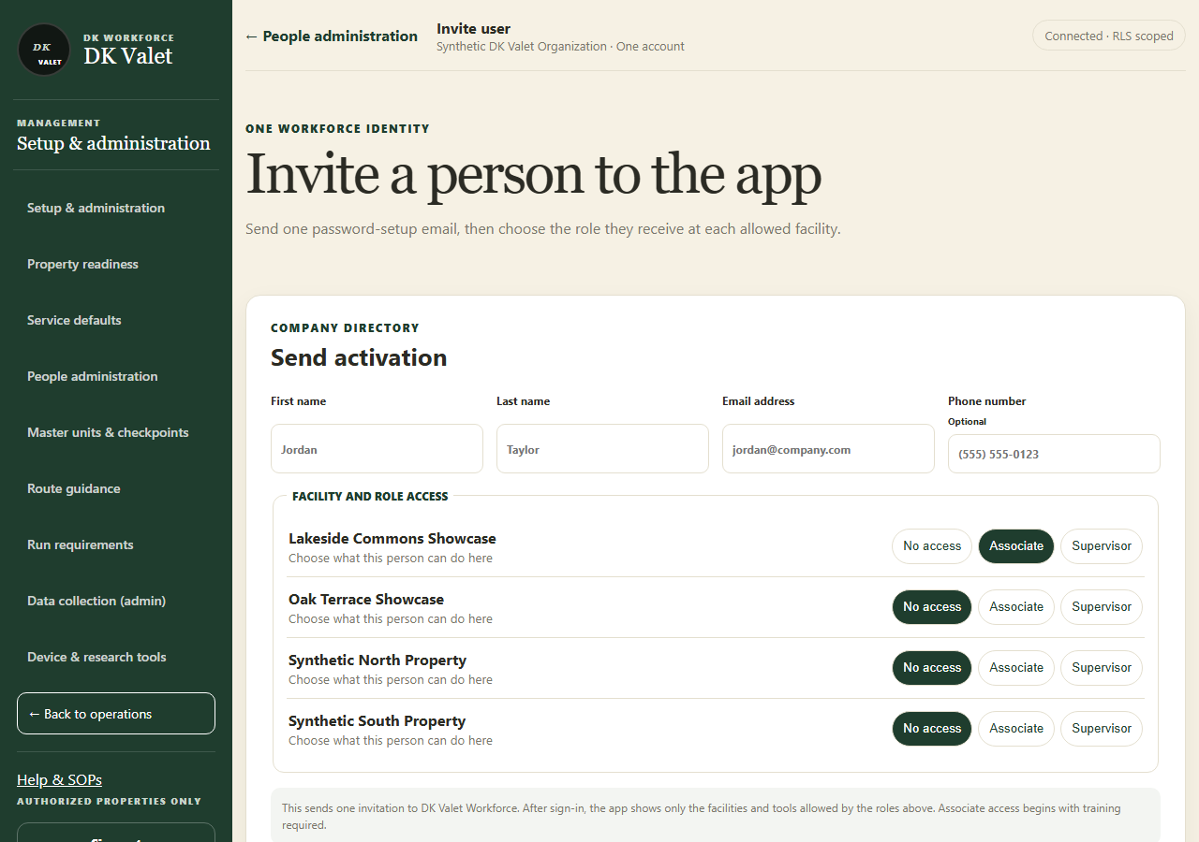
Step 2 · Invite a person to the app: use the property selector and the task controls shown.
Application screenshot with training data.

  - SOP 10 | People and access

Maintain people and property access
Keep contact records and property roles accurate.
For Web and mobile · Administrator / Supervisor
Before you start Supervisors can manage property roles at their own properties. Organization-wide contact and account security controls remain administrator-only.
Open People or Manage > People administration

Step 1 Find the person
Search People by name or email and open the correct person. Check the identity before editing.

Step 2 Update contact details
Where available, edit the contact fields and enter the reason. Save the contact change and wait for confirmation.

Step 3 Review each property role
Open the property access controls. Choose the intended role or remove access using the available options. An organization-wide role may also grant access.

Step 4 Save the property change
Enter the required reason and save or confirm the change. Reopen the person and check the resulting property role.

Step 5 Review training separately
Open Property access & training for work eligibility. An account or property role alone does not establish eligible training.
Check your result The person’s saved contact details and intended property scopes are shown.
If something goes wrong If you cannot manage a listed property, ask an administrator who can. A preferred/default property does not grant authority.
See the picture reference on the next page.

SOP 10 Picture reference
  - Maintain people and property access
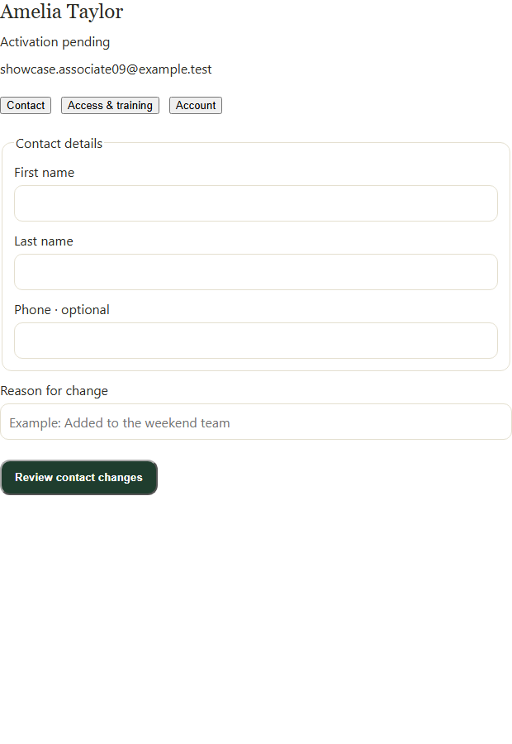
Step 2 · Open the person, choose Contact or Access & training, and review changes before confirming.
Application screenshot with training data.

  - SOP 11 | People and access

Record property access and training eligibility
Make a worker eligible for the property when the training requirement has been satisfied.
For Web and mobile · Administrator / Supervisor
Before you start Use an existing workforce identity and verify the training status through your normal process.
Open Manage > People > Property access & training

Step 1 Select property and worker
Open the property access and training screen, choose the property and locate the employee in the organization roster.

Step 2 Review the current record
Check existing assignment, effective dates and training status before changing them.

Step 3 Record the approved status
Use the access/training form to enter the intended effective access and actual training status. Provide the required audit reason.

Step 4 Save and verify eligibility
Submit and refresh. Check the employee appears as eligible for the full shift window when assigning a shift.
Check your result The property roster displays the intended access and training status.
If something goes wrong If the employee is not selectable, review effective dates, account status and training. Do not label incomplete training eligible to bypass scheduling.
See the picture reference on the next page.

SOP 11 Picture reference
  - Record property access and training eligibility
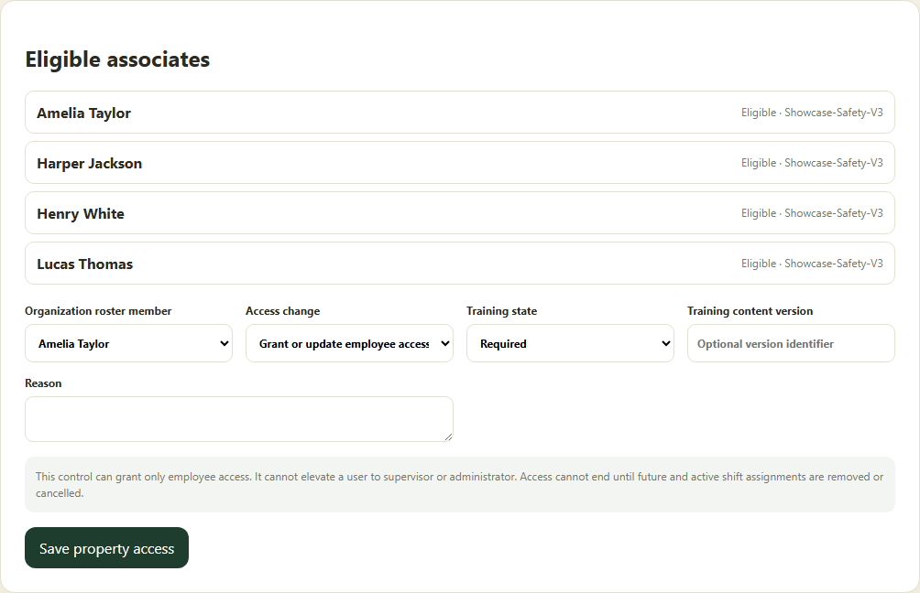
Step 3 · Review eligibility and use the property access and training form.
Application screenshot with training data.

  - SOP 12 | People and access

Use account security controls
Perform an approved password, session or account-status action for the correct person.
For Web and mobile · Administrator
Before you start Company administrator access and a clear operational reason are required.
Open People administration > Person > Account security

Step 1 Open the correct account
Find the person and open Account security. Verify name, email and current Active or Inactive status.

Step 2 Choose the action
Read the description under Account action. Choose the specific password, session or activation action needed.

Step 3 Enter required details
Enter the reason. If setting a temporary password, follow the displayed length requirement and share it privately.

Step 4 Review and confirm
Select Review account change. Verify the named person and action, then select Confirm account change.

Step 5 Verify the result
Wait for Account change completed and check the refreshed state. Ask the affected person to complete any required password setup.
Check your result The account action completes and the refreshed status matches the intended action.
If something goes wrong If the result is uncertain, refresh before retrying. Account changes do not grant new property access.
See the picture reference on the next page.

SOP 12 Picture reference
  - Use account security controls
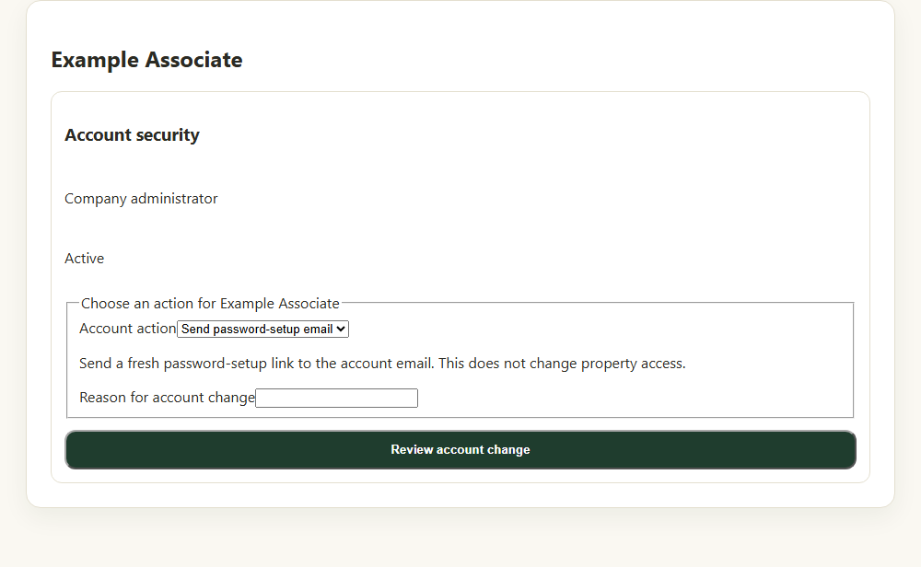
Step 2 · Choose an account action and enter the reason before reviewing the change.
Application component preview with training data. Native permission prompts may differ.

  - SOP 13 | Scheduling

Read the staffing calendar
Find open service windows and distinguish assignment from acceptance.
For Web and mobile · Administrator / Supervisor
Before you start Recurring service times should already be saved for the property.
Open Schedule

Step 1 Choose the week and property
Open Schedule. Use Previous week or Next week and the Property filter. Times are local to each property.

Step 2 Filter staffing status
Use Needs people, Waiting for acceptance or Fully accepted to find the work requiring attention.

Step 3 Open a day or shift
Select a shift card to see the required people, current assignments and gaps. On phones use the day selector and pagination.

Step 4 Inspect person view when needed
Open View options & assignment tools and switch Calendar rows to Person. Select a person to review their week.
Check your result You can identify uncovered time and shifts still waiting on worker replies.
If something goes wrong Fully accepted means staffing is confirmed; it does not mean the run was completed. Clear filters before concluding a shift is missing.
See the picture reference on the next page.

SOP 13 Picture reference
  - Read the staffing calendar
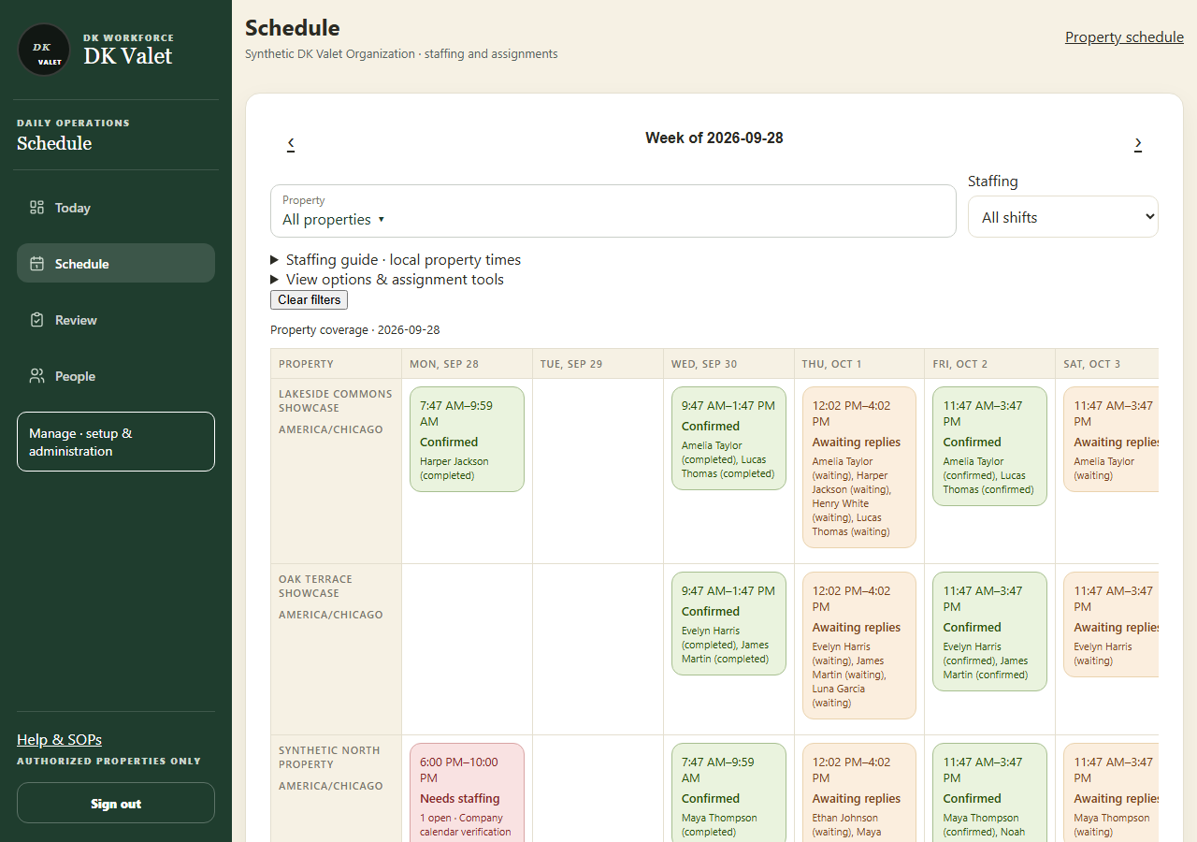
Step 2 · Schedule: use the property selector and the task controls shown.
Application screenshot with training data.

  - SOP 14 | Scheduling

Assign people to a service window
Assign eligible people and review overlap warnings before saving.
For Web and mobile · Administrator / Supervisor
Before you start Property access and training must cover the entire shift.
Open Schedule > Service window

Step 1 Open the service window
Select the correct property, week and window in Schedule. Review time, required headcount and current gaps.

Step 2 Choose the workers
In Who is working? select eligible employees. Read any eligibility or overlap messages. Add shift instructions if needed.

Step 3 Review the change
Enter Reason for change and select Review assignments. Read the confirmation and any overlap warning.

Step 4 Confirm assignments
Confirm assignments if correct. If a warning is acceptable after review, use Save anyway. Cancel to revise the draft.

Step 5 Track the replies
Refresh the calendar and check the new assignments. They await each person’s reply; follow up on outstanding acceptance.
Check your result The calendar shows the intended assignees and their response status.
If something goes wrong An overlap warning may be advisory, but access and training restrictions still apply. Protected workers on an active run cannot be removed.
See the picture reference on the next page.

SOP 14 Picture reference
  - Assign people to a service window
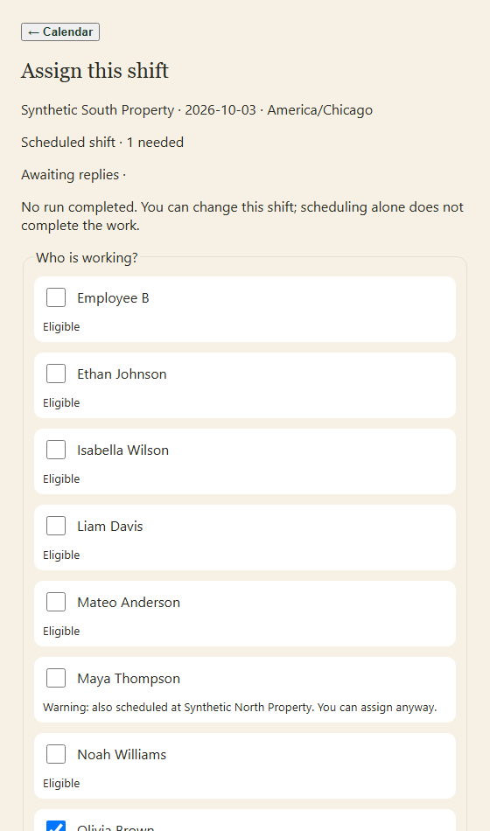
Step 2 · Select eligible people and read overlap warnings. Scroll to the reason and review controls below.
Application screenshot with training data.

  - SOP 15 | Scheduling

Create edit or cancel a dated shift
Maintain a specific shift while preserving work already recorded.
For Web and mobile · Administrator / Supervisor
Before you start Confirm the property, local date, employees and whether a run has started.
Open Property Schedule or Schedule & requests

Step 1 Open the property schedule
Use the property schedule tools to create a shift or open the existing dated shift for editing.

Step 2 Enter permitted changes
Set Starts (property time), Ends, Property phase, Route notes and eligible employees. Locked fields remain unchanged when work has started.

Step 3 Review and save
Use Schedule shift or Save schedule change. Read the overlap confirmation and save only if the details are correct.

Step 4 Cancel only when appropriate
For an eligible shift, enter Cancellation reason and use Cancel shift. A started or protected shift may block cancellation.

Step 5 Check the saved outcome
Refresh and inspect assignments, status and change history. Workers receive schedule updates that they must review.
Check your result The dated shift reflects the saved change and retains its historical work.
If something goes wrong When a field is locked, read its on-screen guidance. Use a separate future shift instead of trying to rewrite active or historical work.
See the picture reference on the next page.

SOP 15 Picture reference
  - Create edit or cancel a dated shift
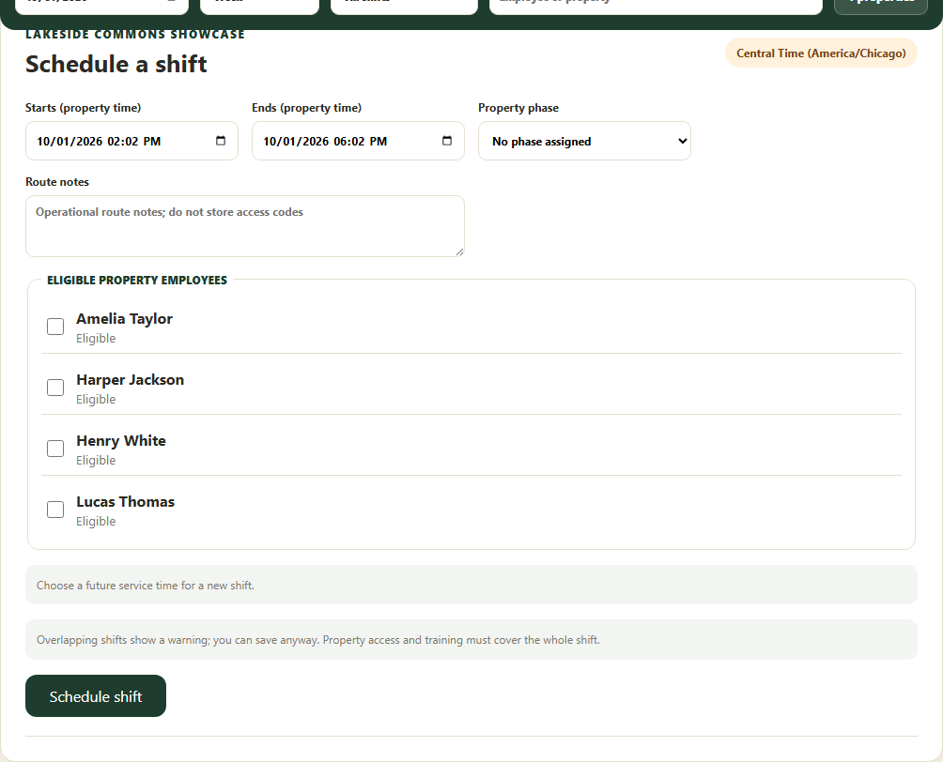
Step 2 · Use property-local dates and eligible employees for a dated shift.
Application screenshot with training data.

  - SOP 16 | Scheduling

Review a time off request
Approve or decline a request and resolve the staffing impact separately.
For Web and mobile · Administrator / Supervisor
Before you start Review the employee, property and full requested interval.
Open Review > Time off & coverage

Step 1 Open requests
Choose Review, then Time off & coverage. On mobile open Requests for the property.

Step 2 Inspect the time off request
Read requested dates, local times, note and current status. Compare against the staffing schedule.

Step 3 Record the decision
Choose the available approval or decline decision, enter the decision note and submit the review.

Step 4 Check staffing separately
Refresh the request status. If approved leave conflicts with a shift, adjust staffing or arrange coverage; the request does not automatically cancel an assignment.
Check your result The recorded decision appears on the request and any staffing gap has a separate plan.
If something goes wrong If the request changed before saving, refresh and review its latest state.
See the picture reference on the next page.

SOP 16 Picture reference
  - Review a time off request
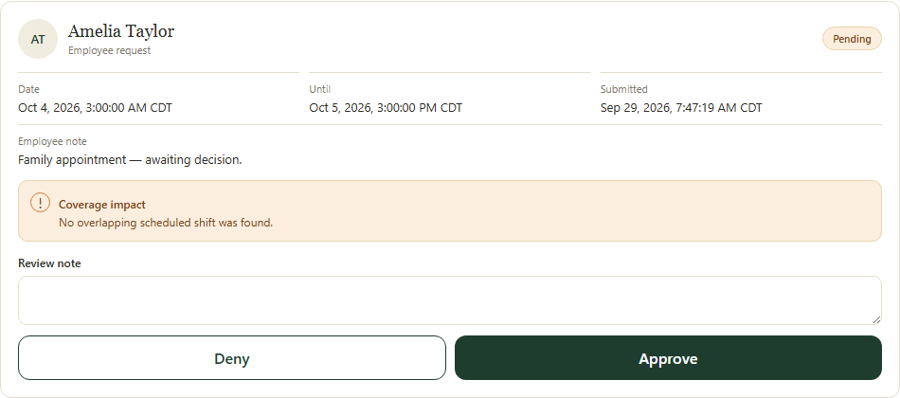
Step 3 · Read the request and coverage impact before recording the approval or denial.
Application screenshot with training data.

  - SOP 17 | Scheduling

Request coverage and assign a replacement
Find a qualified replacement and complete the separate assignment change.
For Web and mobile · Administrator / Supervisor
Before you start Identify the shift and employee being replaced.
Open Review > Time off & coverage

Step 1 Open a coverage request
Choose the property and shift, identify the worker needing replacement and enter the required reason or note. Submit the request.

Step 2 Review candidate responses
Refresh coverage requests and inspect candidates’ availability, eligibility and responses.

Step 3 Choose the candidate
Use the candidate decision controls to select the suitable person or decline a response, with the required note.

Step 4 Finish the assignment
Open Finish assignment for the selected replacement. Review the proposed employee list, retain other workers and save the separate schedule change.

Step 5 Confirm acceptance or cancel the request
Check the replacement in Schedule and track their acceptance. If coverage is no longer needed, use the request cancellation control and reason.
Check your result The replacement is assigned in the calendar; selection alone is not treated as completed staffing.
If something goes wrong If the shift changed or started, the replacement draft needs review. Reopen the current shift before changing assignments.
See the picture reference on the next page.

SOP 17 Picture reference
  - Request coverage and assign a replacement
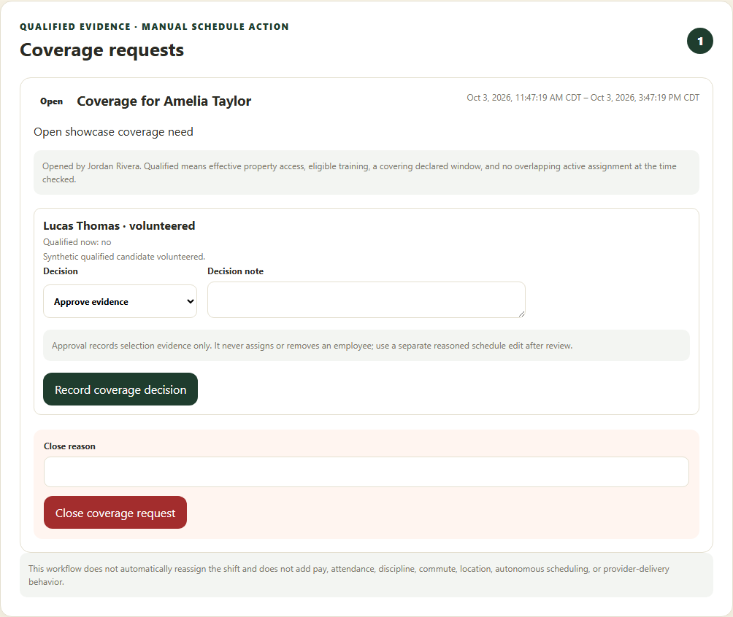
Step 3 · Candidate selection and the separate shift assignment are distinct actions.
Application screenshot with training data.

  - SOP 18 | Daily operations

Monitor daily and district operations
Review current work and act on property-specific exceptions.
For Web and mobile · Administrator / Supervisor
Before you start Only authorized properties are shown. Refresh before relying on stale information.
Open Today

Step 1 Open Today
Choose the company or district and selected property scope. Review the date, current work and attention counts.

Step 2 Inspect the map and property list
Choose a property or worker to focus its boundary and details. Check last-seen time and reported accuracy.

Step 3 Review incomplete information
Read unknown, degraded, stale, offline or permission warnings alongside progress. Missing updates do not establish absence or missed service.

Step 4 Open the relevant task
Use Schedule for staffing, Review for exceptions, or the selected run to inspect evidence. Refresh after addressing the issue.
Check your result You have identified the property and work item that requires follow-up.
If something goes wrong District totals may be incomplete when individual data loads fail. Use the shown freshness and warning labels.
See the picture reference on the next page.

SOP 18 Picture reference
  - Monitor daily and district operations
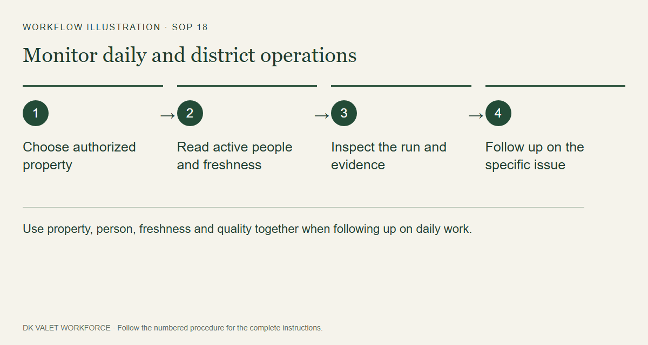
Step 2 · Use property, person, freshness and quality together when following up on daily work.
Workflow illustration. Follow the complete numbered instructions on the previous page.

  - SOP 19 | Daily operations

Record a handoff and review an exception
Leave a property-specific handoff or record the outcome of an exception review.
For Web and mobile · Administrator / Supervisor
Before you start Open the exact property, shift or run that needs follow-up.
Open Today or Review > Needs attention

Step 1 Inspect the item
Read the exception or existing handoff and open the associated run or staffing details when needed.

Step 2 Write the operational note
Use the handoff or review form. Describe the observed issue and next action without access codes, medical details or unsupported location claims.

Step 3 Review the decision
Choose the available review outcome where required. Verify the selected property and the note before confirmation.

Step 4 Save and verify
Submit the form and inspect the saved handoff or review state. Communicate urgent issues through the established supervisor channel.
Check your result The note or review is retained on the correct operational item.
If something goes wrong Marking an exception reviewed does not rewrite tracking evidence or prove service completion.
See the picture reference on the next page.

SOP 19 Picture reference
  - Record a handoff and review an exception
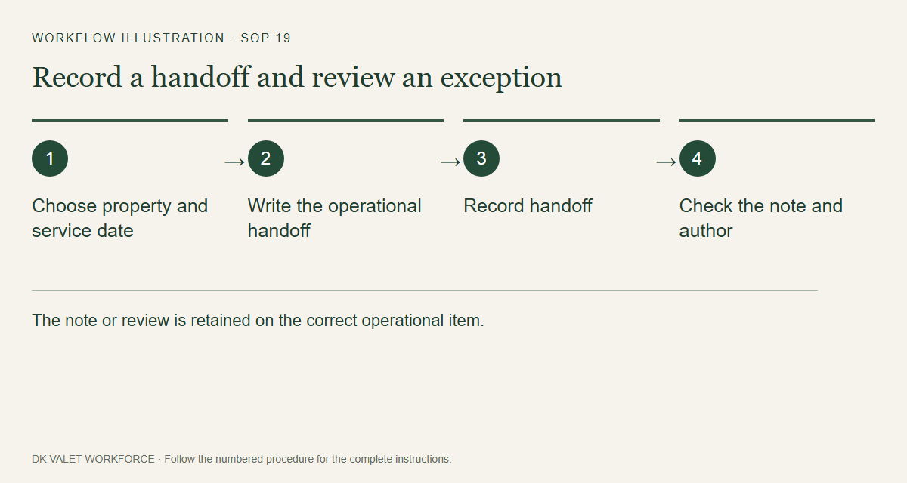
Step 2 · The note or review is retained on the correct operational item.
Workflow illustration. Follow the complete numbered instructions on the previous page.

  - SOP 20 | Run review

Find and inspect a completed run
Locate a run and interpret its evidence in context.
For Web and mobile · Administrator / Supervisor
Before you start Know the property and approximate work date.
Open Review > Run history

Step 1 Filter history
Open Run history, choose the authorized property and apply available date, person or status filters.

Step 2 Open the run
Select the intended employee and run. Verify property, start and end times and run status.

Step 3 Read evidence quality
Review GPS freshness and accuracy, permission and device information, upload state and any gaps.

Step 4 Compare the recorded evidence
Use route replay and checkpoint or unit evidence. Read inferred visit results separately from explicit marks and the employee finish statement.

Step 5 Follow up on exceptions
Open the closeout review or record the appropriate operational follow-up. Keep unknown results unknown until supporting evidence exists.
Check your result Your review identifies what was recorded, what was inferred and what remains unresolved.
If something goes wrong An ordinary phone location does not prove an exact indoor unit or floor.
See the picture reference on the next page.

SOP 20 Picture reference
  - Find and inspect a completed run
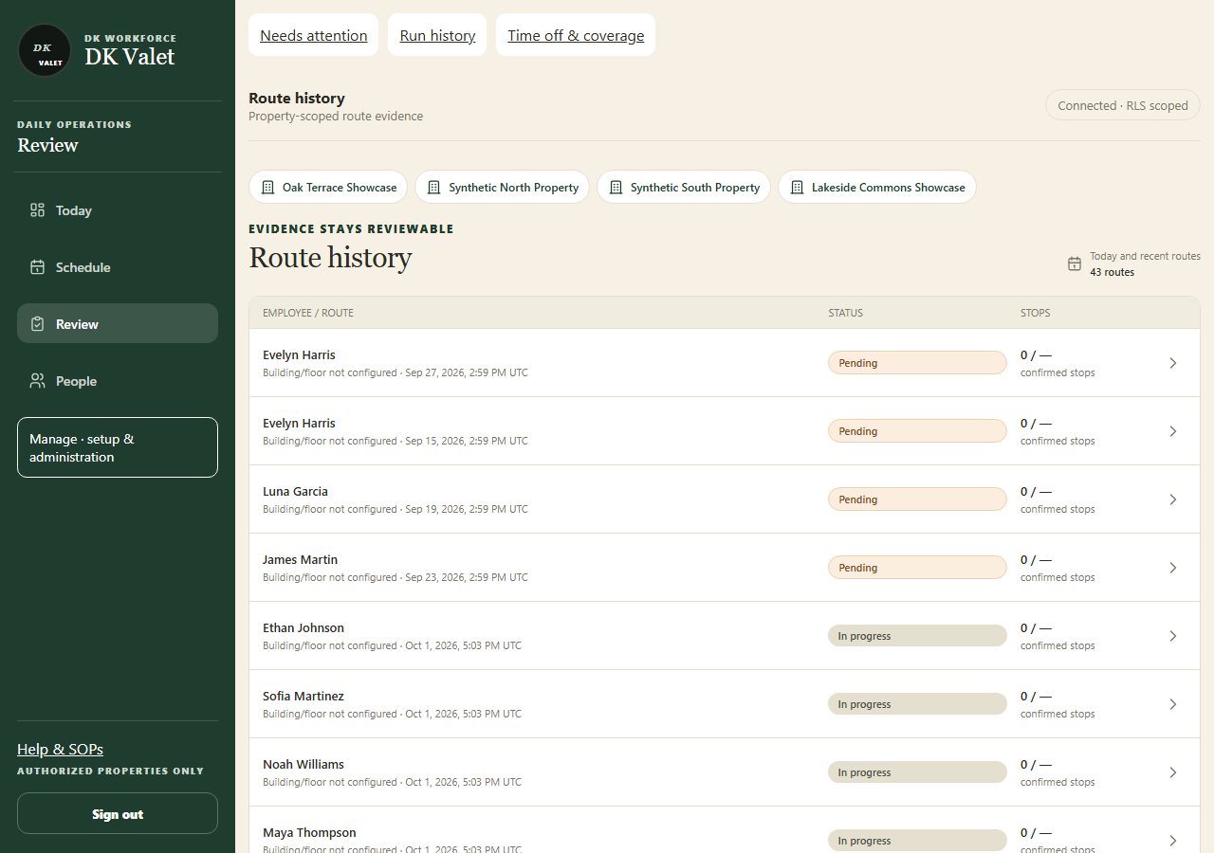
Step 2 · Route history: use the property selector and the task controls shown.
Application screenshot with training data.

  - SOP 21 | Run review

Replay compare and export run evidence
Compare an associate run with the approved reference and export permitted evidence.
For Web and mobile · Administrator / Supervisor
Before you start Open the correct run. Analysis may need accepted uploads and processing before results appear.
Open Run history > Run detail

Step 1 Open replay and comparison
From the run detail open its route replay, analysis or employee-run comparison view. Check which reference version is being used.

Step 2 Inspect layers and timing
Use the available playback, time, unit and path controls. Read gaps, uncertainty and quality labels beside the path.

Step 3 Review analysis status
Refresh pending results. Where offered, use the authorized analysis action, then wait for its result instead of repeatedly submitting.

Step 4 Export when needed
On web use the offered evidence export link. Check the property and run in the exported file and share it only with authorized recipients.
Check your result The comparison or export remains tied to the selected run and property.
If something goes wrong Different path models are interpretations of the same evidence. A drawn line or inferred visit is not a checkpoint scan.
See the picture reference on the next page.

SOP 21 Picture reference
  - Replay compare and export run evidence
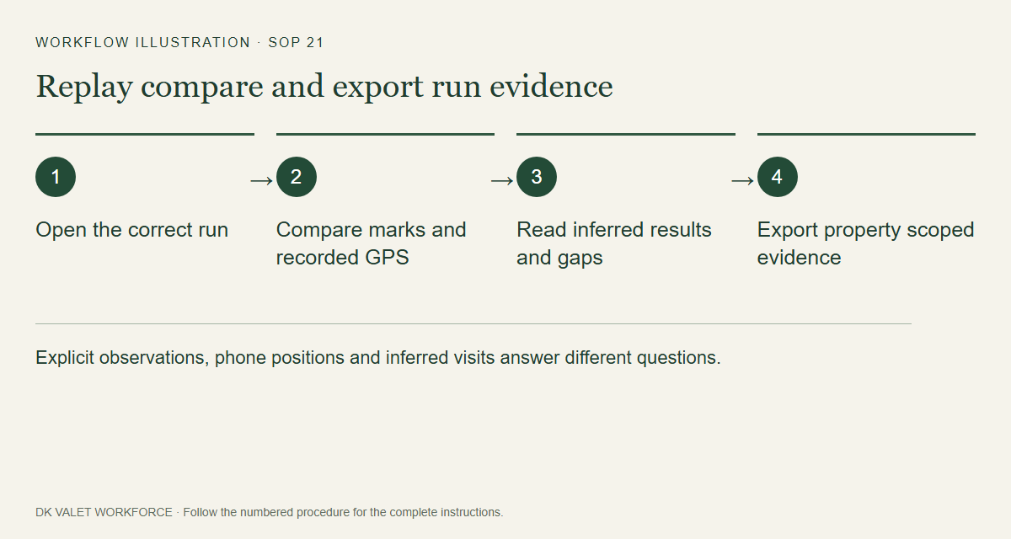
Step 2 · Explicit observations, phone positions and inferred visits answer different questions.
Workflow illustration. Follow the complete numbered instructions on the previous page.

  - SOP 22 | Property setup

Start a mobile property setup walk
Start an authorized setup recording before marking the unit route.
For Mobile · Administrator / Supervisor
Before you start Use the approved sensor-capable app build, a registered device, setup permission and reviewed boundary. Clock out of routine tracking first.
Open Manage > Property > Property readiness & setup runs

Step 1 Choose the property
Open its setup task. Read property instructions or What is recorded? and confirm the address.

Step 2 Choose recording mode
Choose Screen-off or Screen-on only and read the consent text. Screen-on recording pauses when the app is left or the phone locks.

Step 3 Check your position
Tap Show my live position. Allow the requested precise location permissions and move safely to the authorized start area.

Step 4 Start the recording
When start checks pass, use Agree & start background setup or Start screen-on setup. The button depends on the selected mode.

Step 5 Choose phone position
Select where you will carry the phone and keep it there while walking. Confirm the app shows the active setup walk.
Check your result Walk to the next unit is available and recording status is shown for the selected property.
If something goes wrong A map preview is not a started setup run. If sensors, permission or boundary checks fail, resolve the displayed issue before starting.
See the picture reference on the next page.

SOP 22 Picture reference
  - Start a mobile property setup walk
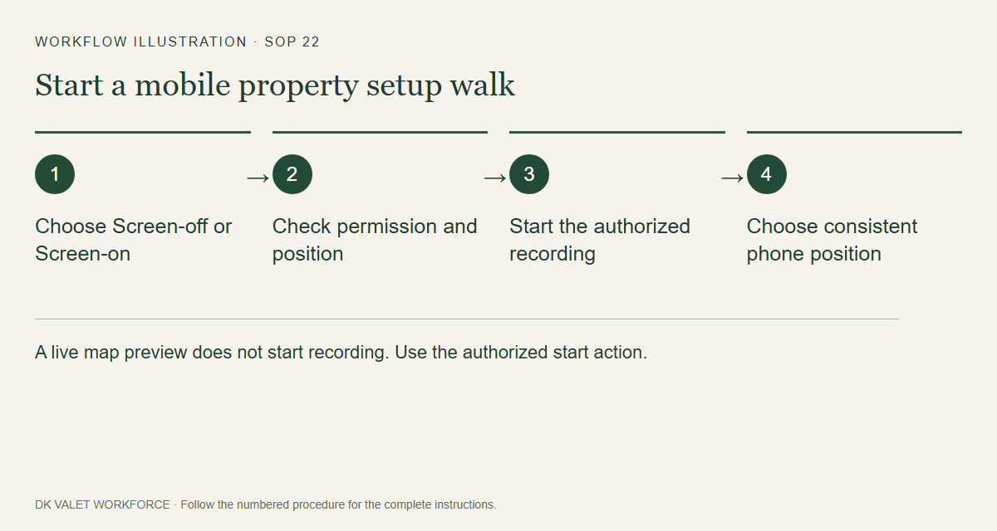
Step 2 · A live map preview does not start recording. Use the authorized start action.
Workflow illustration. Follow the complete numbered instructions on the previous page.

  - SOP 23 | Property setup

Mark units and add optional setup photos
Record explicit unit labels and supporting observations during the setup walk.
For Mobile · Administrator / Supervisor
Before you start An authorized setup recording must be active on this device.
Open Active setup > Walk to the next unit

Step 1 Walk to the actual unit
Follow the property safely and stop at the physical door or checkpoint you intend to record.

Step 2 Open the unit marking task
Use the mark-unit action. Copy the posted Unit number exactly; this field is required. A configured numbering rule can decode the posted label into building and floor for future marks. Explicit entries take precedence; an unmatched label stays unknown.

Step 3 Add identification details
Add the Building and Floor labels when known. Optional notes should help identify the door. Add a photo only when useful and appropriate.

Step 4 Save the unit
Review the label, optional details and measured position, then save using the displayed unit-save action. Verify the units-saved count.

Step 5 Continue the walk
Return to the map and proceed to the next unit. Use Status to inspect capture and upload health during a long walk.
Check your result The new mark appears in the saved unit count and later in the setup review.
If something goes wrong A saved mark records your explicit observation. Its phone coordinates retain their accuracy limits and are not exact indoor positioning.
See the picture reference on the next page.

SOP 23 Picture reference
  - Mark units and add optional setup photos
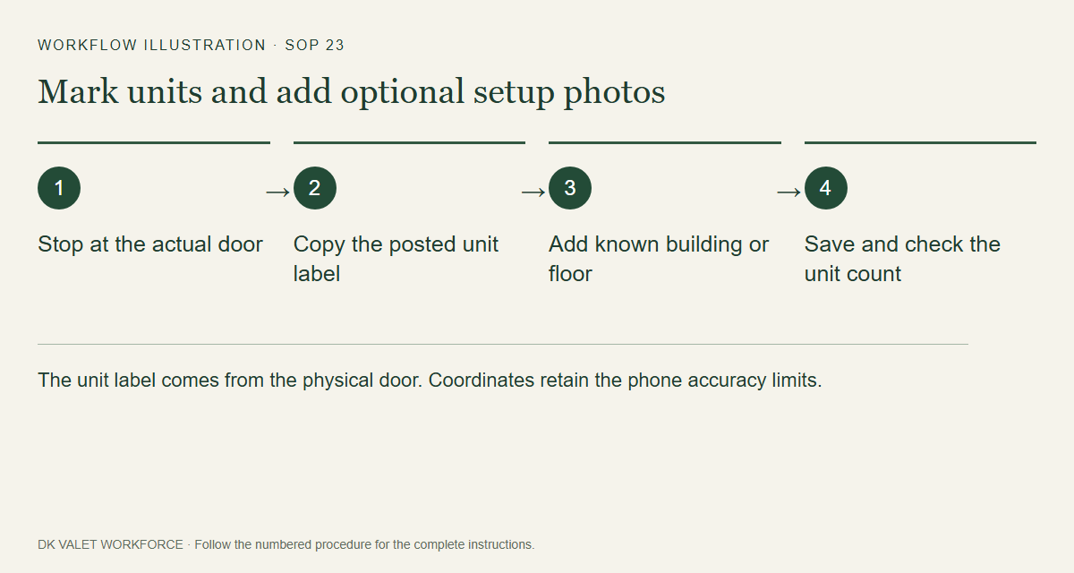
Step 2 · The unit label comes from the physical door. Coordinates retain the phone accuracy limits.
Workflow illustration. Follow the complete numbered instructions on the previous page.

  - SOP 24 | Property setup

Finish recover and upload a setup walk
Stop setup recording and verify pending evidence is uploaded.
For Mobile · Administrator / Supervisor
Before you start Keep the same phone and account while local evidence is waiting.
Open Active setup > Status or Review and finish

Step 1 Inspect capture status
Open Status to compare saved-on-phone, accepted-by-server, waiting-to-upload and rejected/dropped counts.

Step 2 Recover a paused or interrupted walk
Return to the existing setup task. Use Upload / resume recovery or the displayed retry control for that run; follow any device-ownership warning.

Step 3 Review the finish summary
Use the review-and-finish action. Check units marked and pending batches before confirming Finish.

Step 4 Keep pending evidence available
Finish stops GPS and motion collection. Keep the phone connected and use the upload/recovery action if data remains pending.

Step 5 Open the completed review
Use View last setup or the saved setup run to inspect accepted marks and capture gaps.
Check your result The setup run is finished and its accepted evidence can be reviewed; any remaining upload issue is explicitly identified.
If something goes wrong Do not clear app storage or switch accounts to fix a pending queue. If another device owns an active run, contact the supervisor responsible for it.
See the picture reference on the next page.

SOP 24 Picture reference
  - Finish recover and upload a setup walk
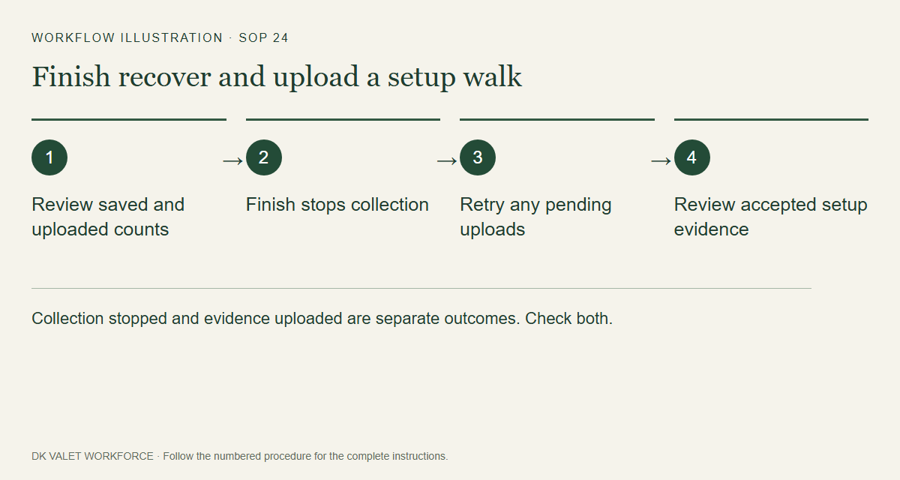
Step 2 · Collection stopped and evidence uploaded are separate outcomes. Check both.
Workflow illustration. Follow the complete numbered instructions on the previous page.

  - SOP 25 | Property setup

Review setup walks and unit records
Inspect a completed setup recording and review its explicit unit marks.
For Web and mobile · Administrator / Supervisor
Before you start At least one setup walk must have accepted evidence.
Open Property readiness > Review setup walks and unit records

Step 1 Open the completed walk
Select the property and choose View walk and captured data or the completed setup review on mobile.

Step 2 Check recording completeness
Compare recorded interval, GPS points, unit marks, samples and upload or gap warnings. Use replay and time controls to inspect the whole walk.

Step 3 Inspect marked unit sequence
Check unit labels, building/floor observations, duplicates and their capture order. Read observed coordinates with accuracy metadata.

Step 4 Compare server analysis models
After uploads finish, open Models on mobile or Model analysis in web review. Select V1, V4, V5, V6 or V7, then Analyze recording. V7 is a sparse-GPS experiment: compare GPS budgets, missing coverage and the 90% within 5 m target; offline controls use future GPS. Inspect the route and metrics; open Details for provenance. Pause stops after the current saved path step; Analyze resumes. Refresh models loads server additions. Download full JSON on web or share a mobile summary, keeping the model revision and input digest with your independent observer log. Results remain estimates and do not change the published master.

Step 5 Review unit records on web
Where a unit is awaiting review, set its checkpoint label, order, decision and review note. Use Record review to approve/promote or reject the draft.

Step 6 Continue to master review
Choose appropriate reviewed marks in the master workspace. Reviewing a mark alone does not publish an associate route.
Check your result Each reviewed unit retains its decision and the accepted walk is ready for master-reference review.
If something goes wrong Incomplete uploads and GPS gaps must stay visible. Do not infer an exact floor from pressure or GPS alone.
See the picture reference on the next page.

SOP 25 Picture reference
  - Review setup walks and unit records
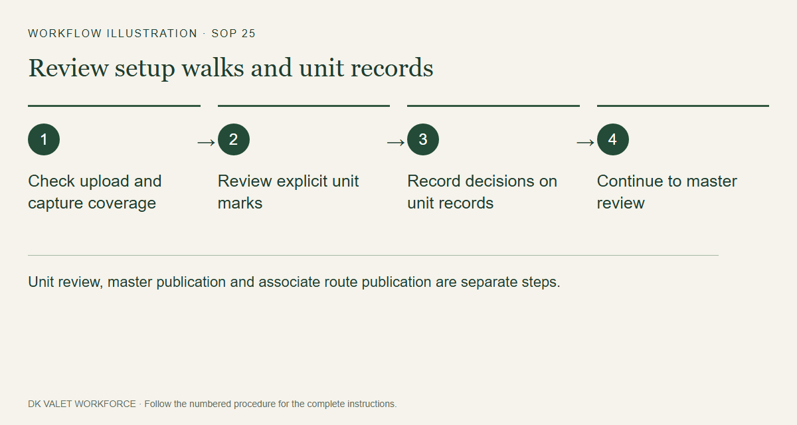
Step 2 · Unit review, master publication and associate route publication are separate steps.
Workflow illustration. Follow the complete numbered instructions on the previous page.

  - SOP 26 | Property setup

Review and publish the master reference
Choose an ordered, reviewed reference from setup walks.
For Web · Administrator / Supervisor
Before you start Review setup evidence first and verify that the correct property is selected.
Open Manage > Master units & checkpoints > Master review

Step 1 Select the source runs
Select run A and an optional run B. Each run has one Model selector: choose Original unit marks or an analysis model. A saved model revision appears immediately; Analyze recording draws the new result on the main map, including V6. Expand Saved revisions to inspect an older result.

Step 2 Inspect units and differences
Use map, order, floor and differences controls to check labels, sequence, repeated marks and position differences.

Step 3 Build the draft
Choose original marks or a saved revision, then select unit marks or Use entire run A. On-demand model previews cannot supply publication coordinates until they have a matching saved path. Review the repeated-unit choice, order and source revision. Changing the displayed model preserves units already in the draft.

Step 4 Review publication
Advance through the draft review, enter the required reason and inspect the publication summary.

Step 5 Publish and check the version
Confirm the master publication and verify its saved version. Continue to Publish the associate route to make the units available to future associate runs.
Check your result A versioned master reference is saved with its selected ordered unit sources.
If something goes wrong Changing a comparison model should not be treated as automatically changing the published master or an active run.
See the picture reference on the next page.

SOP 26 Picture reference
  - Review and publish the master reference
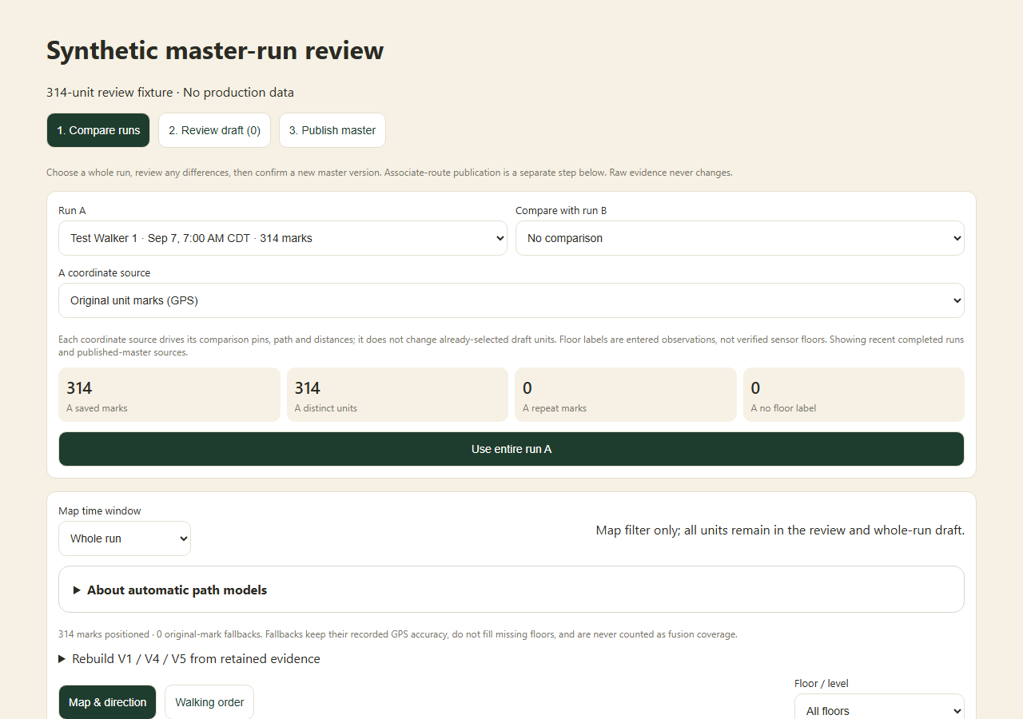
Step 2 · Compare the selected setup runs, coordinate source and unit counts before building a master draft.
Application component preview with training data. Native permission prompts may differ.

  - SOP 27 | Property setup

Publish the associate route
Make every unit from the approved master available to future associate runs.
For Web · Administrator / Supervisor
Before you start A complete reviewed master with positioned units must exist.
Open Manage > Master units & checkpoints > Publish the associate route

Step 1 Review the master
Open Publish the associate route for the correct property. Verify the master version and all required units.

Step 2 Name and scope the route
Enter the route name and choose the property default or intended phase using the form. Provide the publication reason.

Step 3 Review publication
Select Review publication. Check route name, scope, master version and total units.

Step 4 Confirm and verify
Confirm the publication. Inspect Current operational routes and return to property readiness to check the unit route requirement.
Check your result The operational route records the intended master version and all its units for future starts.
If something goes wrong A master publication and an associate-route publication are separate actions. Existing runs keep their pinned reference.
See the picture reference on the next page.

SOP 27 Picture reference
  - Publish the associate route
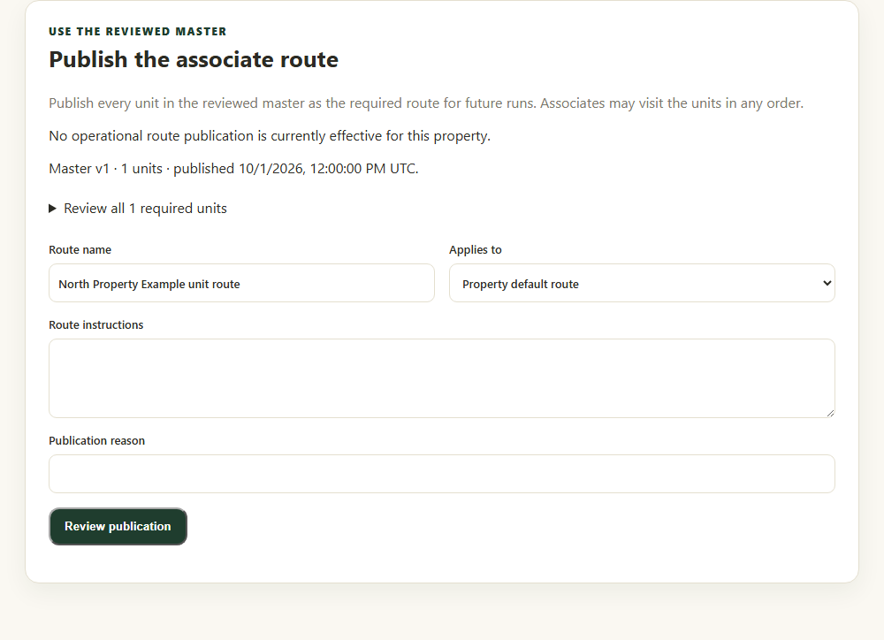
Step 2 · Check the master version, route name, phase and reason before review.
Application component preview with training data. Native permission prompts may differ.

  - SOP 28 | Advanced administration

Maintain checkpoint definitions
Maintain reviewed labels, order and optional reference coordinates.
For Web · Administrator / Supervisor
Before you start Use the correct property and a reviewed source for any coordinates.
Open Manage > Master units & checkpoints

Step 1 Open checkpoint configuration
Select the property and inspect the ground-truth map and configured checkpoints.

Step 2 Add or open a checkpoint
Use Add checkpoint or the existing checkpoint editor. Enter Label, Kind, Building, Floor and Unit label where applicable.

Step 3 Review order and position
Set Sort order. Add optional Latitude and Longitude only from a reviewed reference and preserve the stated uncertainty.

Step 4 Save and inspect
Use the create/update action and wait for success. Review the ordered list and map. Review and publish the operational route separately when required.
Check your result The checkpoint definition is saved in the selected property.
If something goes wrong Editing a reference does not retroactively rewrite raw tracking events or prove a prior unit visit.
See the picture reference on the next page.

SOP 28 Picture reference
  - Maintain checkpoint definitions
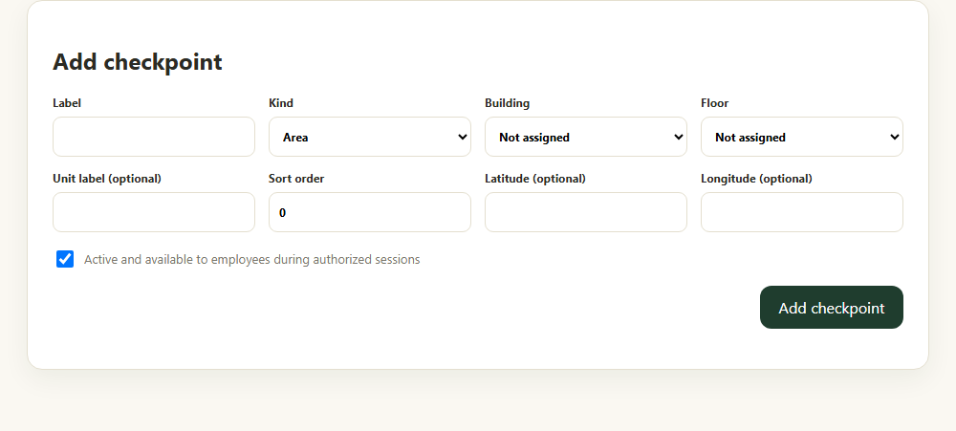
Step 3 · Maintain the checkpoint label, type, order and reviewed position.
Application component preview with training data. Native permission prompts may differ.

  - SOP 29 | Advanced administration

Publish phase guidance and change a shift phase
Maintain phase-specific notes and choose a phase for an eligible shift.
For Web · Administrator / Supervisor
Before you start The property must have configured phases. Confirm no active run is being rewritten.
Open Manage > Route guidance

Step 1 Select property and phase
Open Route guidance and choose the property phase in the guidance form.

Step 2 Write and publish guidance
Enter Route notes, Tracked areas and Tricky areas as requested. Add Publication reason and select Publish guidance version.

Step 3 Change an eligible shift phase
If needed, use Change assigned shift phase. Choose the shift, New property phase and Operational reason.

Step 4 Verify both results
Select Record phase change and check the saved guidance and shift. Active and historical sessions retain their captured configuration.
Check your result Future applicable work uses the saved guidance and the selected eligible shift has the intended phase.
If something goes wrong If no eligible shifts or phases are offered, review configuration and run status. This action does not create, move or cancel a shift.
See the picture reference on the next page.

SOP 29 Picture reference
  - Publish phase guidance and change a shift phase
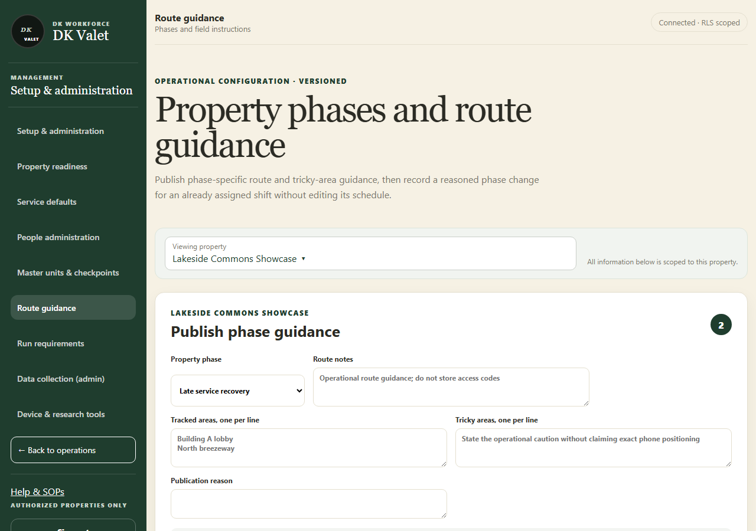
Step 2 · Property phases and route guidance: use the property selector and the task controls shown.
Application screenshot with training data.

  - SOP 30 | Advanced administration

Publish run requirements and review closeout exceptions
Configure explicit checkpoint requirements and review incomplete or unknown closeouts.
For Web · Administrator / Supervisor
Before you start Checkpoints and any required phases must exist.
Open Manage > Run requirements; Review > Run closeouts

Step 1 Choose the property
Open Manage > Run requirements and select the intended property. Current requirements are read-only until you choose Edit requirements.

Step 2 Define a new version
Under Edit requirements > Publish run requirements, enter the template details, phase, checkpoint requirements and route notes. Review required versus optional items.

Step 3 Publish and inspect
Select Publish new version and verify it under Current phase templates. New runs use the applicable effective version.

Step 4 Review exceptions
Open Review > Run closeouts and select the property. The queue starts with Needs review; use search and status filters to find a run or review history. Select a run to inspect accepted, missing and unknown evidence and the employee reason.

Step 5 Record the review
Choose the review decision and note, select Mark as reviewed, then Confirm review.
Check your result The template version or exception review is recorded with its property scope.
If something goes wrong If no template is configured, closeout may remain unknown. A reviewed override does not create missing checkpoint evidence.
See the picture reference on the next page.

SOP 30 Picture reference
  - Publish run requirements and review closeout exceptions
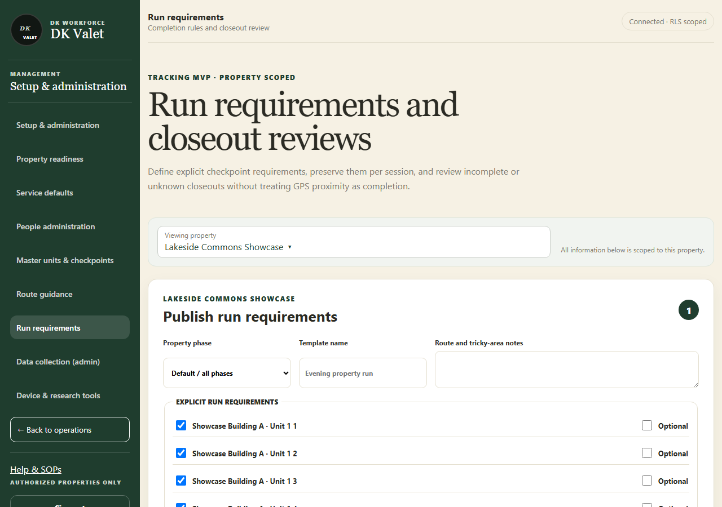
Step 2 · Run requirements and closeout reviews: use the property selector and the task controls shown.
Application screenshot with training data.

  - SOP 31 | Advanced administration

Configure run questions
Publish questions, photo requirements and timing for future runs.
For Web and mobile · Administrator / Supervisor
Before you start Use approved questions and authorized properties. Install Android 69 or iOS 44, or later approved builds, on participating phones before setting expiration dates. Older builds support unlimited questions only.
Open Web: Manage > Property setup > Run questions. Mobile: Operations > Manage > Company run questions, or a property > Run questions.

Step 1 Select the scope
Choose company or property questions and verify the property name. Company questions appear first. Read-only access does not permit publication; company editing requires company administration access.

Step 2 Edit the question
Add or edit the text, clock-in or clock-out step, required answer and none, optional or required photo. Reorder or retire questions in the draft. No questions interrupt an active route.

Step 3 Choose audience and recurrence
Select the applicable properties and employees. Choose every run or a 1–365-day interval per employee and property. An interval advances after an ordinary answer and any attached photo upload, independently of manual review.

Step 4 Set an optional end date
Leave expiration blank for no limit. The chosen date is included in each property’s local time; later newly opened steps omit the question even when its interval is due. Clearing a date removes the limit for future runs.

Step 5 Review and publish
Save each question to the draft, enter a publication reason, review the full selected-scope list and confirm publication. Verify the new version. Existing run questions, responses, photos and review history remain unchanged.

Step 6 Handle an unconfirmed result
Use Retry same publication when offered; reload after an access or version change. Confirm the displayed version before making another edit. Unpublished drafts are lost when the app closes.
Check your result The intended scope shows the new configuration version. No real expiration is set automatically by an app update.
If something goes wrong A saved draft is not published. A required answer may truthfully be No. Keep all participating phones updated before using expiration; Android 68/iOS 43 reject questions carrying an expiration date.
See the picture reference on the next page.

SOP 31 Picture reference
  - Configure run questions
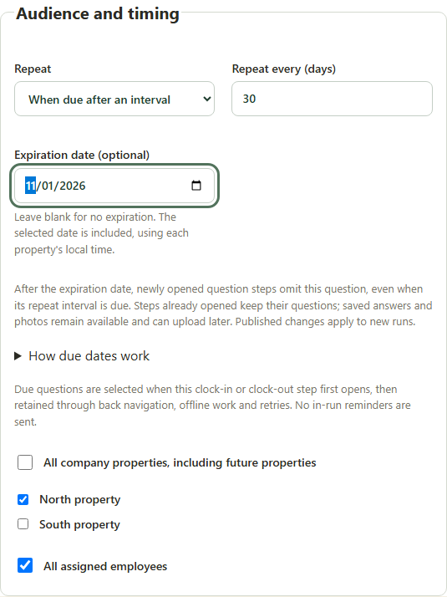
Step 4 · Actual web timing controls with synthetic data. The end date includes the property-local day. This component preview is not a physical-phone screenshot.
Application component preview with training data. Native permission prompts may differ.

  - SOP 32 | Associate work

Use My work and Account and help
Find the next shift, outstanding replies and supervisor contact.
For Mobile · Associate
Before you start Sign in with your own workforce account.
Open My work

Step 1 Refresh your work
Tap Refresh and read the update or warning message. Counts marked unknown need another refresh before you rely on them.

Step 2 Open the next action
Use Prepare for this shift, Return to run / finish, Complete run closeout or Review finished run according to the status shown.

Step 3 Check requests and updates
Open Shifts to accept, Work updates or Coverage opportunities. Use View my calendar and Availability & time off for planning.

Step 4 Open Account
Use Account to inspect notification status, open phone settings or contact your supervisor. Managers can switch to their manager workspace when available.
Check your result You can identify the next task and reach your supervisor when a task is blocked.
If something goes wrong If work data did not load, refresh before assuming there are no assignments or updates.
See the picture reference on the next page.

SOP 32 Picture reference
  - Use My work and Account and help
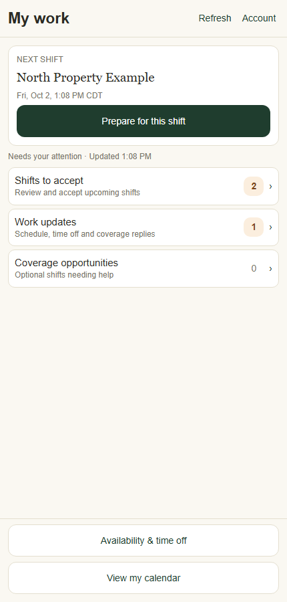
Step 2 · My work shows the next shift, replies and planning actions.
Application component preview with training data. Native permission prompts may differ.

  - SOP 33 | Associate work

View your calendar and accept or decline shifts
Review your assignments and explicitly respond.
For Mobile · Associate
Before you start Confirm the property, date and local time for each assignment.
Open My work > Shifts to accept or View my calendar

Step 1 Open your schedule
Use Shifts to accept for pending replies or View my calendar to browse scheduled work.

Step 2 Inspect the shift
Select the relevant date and shift. Read the property, start and end time, instructions and current assignment response.

Step 3 Respond to the assignment
Use the displayed accept or decline control. When selecting several shifts, review the selected list before confirming acceptance.

Step 4 Check the saved response
Wait for confirmation and refresh the schedule. Use Prepare for this shift when it is time to review start checks.
Check your result The shift shows your saved acceptance or decline response.
If something goes wrong Acknowledging a schedule notification is separate from accepting a shift. If a response is rejected, refresh the latest schedule.
See the picture reference on the next page.

SOP 33 Picture reference
  - View your calendar and accept or decline shifts
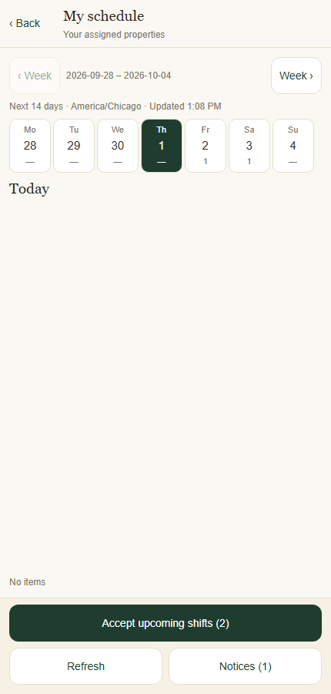
Step 1 · Use the calendar to inspect dates and assigned shifts.
Application component preview with training data. Native permission prompts may differ.

  - SOP 34 | Associate work

Read work updates and reply to coverage opportunities
Acknowledge changes and respond to optional coverage requests.
For Mobile · Associate
Before you start Refresh My work before acting on an old notification.
Open My work > Work updates or Coverage opportunities

Step 1 Open Work updates
Read the schedule, time off or coverage update. Check its property and dates, including old versus new times where shown.

Step 2 Acknowledge the update
Use the receipt or acknowledgment control. Then open the schedule if the assignment itself still needs your response.

Step 3 Open Coverage opportunities
Read each offered property, interval and request. Use the interested/available or decline response offered on screen.

Step 4 Check the final assignment
Refresh replies and your calendar. Volunteering for coverage does not itself assign the shift; wait for the manager’s selection and schedule update.
Check your result Your receipt or coverage response is saved and you know whether a shift was actually assigned.
If something goes wrong Push notifications can be delayed. Work updates in the app remain the place to review changes.
See the picture reference on the next page.

SOP 34 Picture reference
  - Read work updates and reply to coverage opportunities
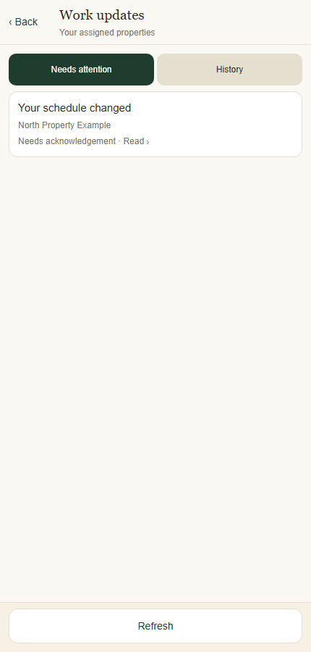
Step 1 · Work updates retains changes that need your attention.
Application component preview with training data. Native permission prompts may differ.

  - SOP 35 | Associate work

Set recurring weekly availability and review extra hours
Set personal recurring hours across currently assigned properties without changing shifts.
For Mobile · Associate / Administrator / Supervisor
Before you start Managers need management access to all of the employee’s assigned properties to edit personal hours.
Open My work > Availability & time off or People > Person > Work hours

Step 1 Open personal hours
From My work select Availability & time off. Managers open the person in People and use the work-hours action. Check whose hours are displayed.

Step 2 Review the current week
Use Weekly hours and the week arrows. Tap a day for details. Refresh hours if the record is stale.

Step 3 Edit the recurring plan
Select Edit weekly hours. Set the effective date and Hours time zone. Enable the days the person is available and use each day’s editor to set start/end time and AM/PM.

Step 4 Review and confirm
Select Review weekly hours. Check effective date, time zone and every enabled day, then Confirm save. Availability does not assign a property or shift.

Step 5 Review earlier extra hours
If Extra hours is shown, inspect earlier one-time availability windows. Associates can open one, choose Remove window and confirm the reviewed change.
Check your result Weekly hours shows the effective recurring plan; any earlier extra-hour window remains separate.
If something goes wrong If a save is unconfirmed, use Resume unconfirmed save and Retry same save. Do not create a second change while the first result is unknown.
See the picture reference on the next page.

SOP 35 Picture reference
  - Set recurring weekly availability and review extra hours
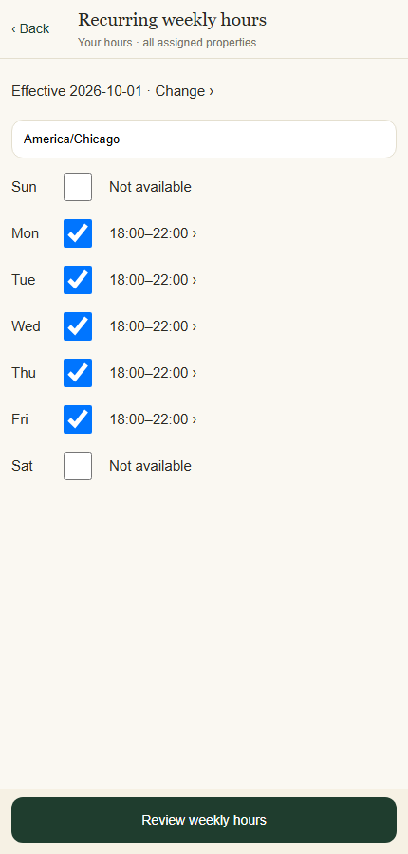
Step 3 · Set the effective date, time zone, available days and recurring hours.
Application component preview with training data. Native permission prompts may differ.

  - SOP 36 | Associate work

Request or cancel time off
Request time away and track the manager’s decision.
For Mobile · Associate
Before you start The current mobile request applies to all currently assigned properties. Managers decide each property’s request separately.
Open My work > Availability & time off > Time off

Step 1 Open your personal hours
From My work select Availability & time off, then Request time off.

Step 2 Set dates and hours
Choose First day and Last day. Keep All day time off enabled for whole days, or edit the start/end hours. Verify the displayed time zone and assigned-property count.

Step 3 Review your request
Add an optional note without medical details. Select Review time off. Check the full interval and the notice that it applies to all currently assigned properties.

Step 4 Save and inspect decisions
Select Confirm save. Open the Time off tab and tap the saved group to inspect each property’s status and manager response.

Step 5 Cancel active requests when needed
Open the saved time-off group, choose Cancel active requests where offered, review the interval and Confirm save. Refresh and check each resulting status.
Check your result The request and its current decision are visible in your list.
If something goes wrong A time off request, even if approved, does not automatically cancel your existing assigned shift. Contact your supervisor about conflicting work.
See the picture reference on the next page.

SOP 36 Picture reference
  - Request or cancel time off
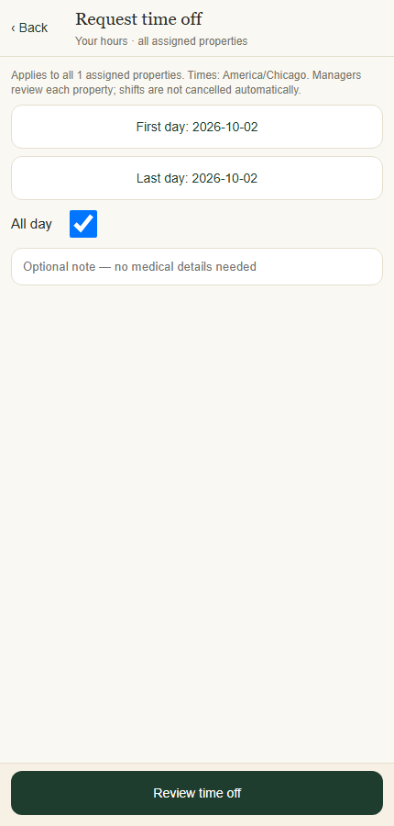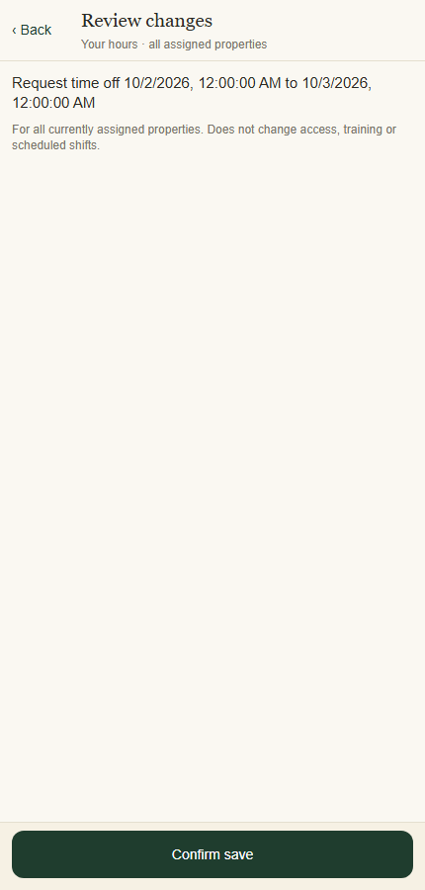
Left · Step 2 · Review the time zone and all assigned properties before requesting time off.
Right · Step 3 · Confirm save applies the reviewed request; existing shifts stay unchanged.
Application component preview with training data. Native permission prompts may differ.

  - SOP 37 | Associate work

Prepare for a shift and clock in
Complete the displayed checks and start an authorized run.
For Mobile · Associate
Before you start Use your assigned account and approved app. Be at the correct property with location services available.
Open My work > Prepare for this shift

Step 1 Verify the shift
Read the selected property, date and time on Prepare your route. Use the schedule if a different assignment should be selected.

Step 2 Resolve start checks
Open the first missing check or See what to do. Refresh checks after access, route, device or policy issues have been corrected. Employees cannot clock in before the scheduled start. Supervisors use Today then Clock in at a property for support work outside a scheduled window. Both must be inside the configured boundary.

Step 3 Read all instructions
Use Next instruction until the last page, then I've read this — continue.

Step 4 Check your position
Open Property map and Show my position. Use directions to a safe entrance and check the measured position and accuracy against the boundary. Previewing does not clock you in.

Step 5 Clock in
When the scheduled time and all other checks are ready, select Clock in. Confirm a second run only if more work is actually needed. Continue to the due run questions and requested photos (SOP 38).
Check your result Clock-in is accepted and the Run questions step or active route opens.
If something goes wrong For permission issues use Check location permissions or Open phone settings. For missing access or unpublished units contact the supervisor; repeated start attempts will not fix configuration.
See the picture reference on the next page.

SOP 37 Picture reference
  - Prepare for a shift and clock in
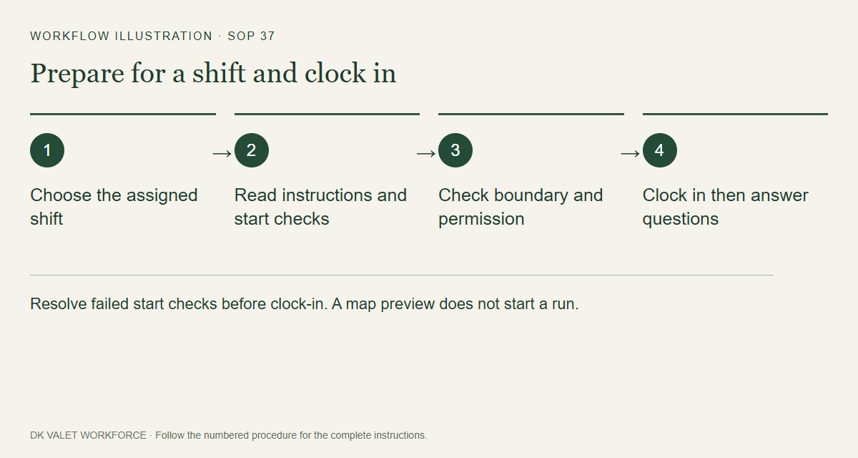
Step 2 · Resolve failed start checks before clock-in. A map preview does not start a run.
Workflow illustration. Follow the complete numbered instructions on the previous page.

  - SOP 38 | Associate work

Answer run questions and add photos
Save truthful answers and requested photos before opening the route.
For Mobile · Associate
Before you start Clock-in must already be accepted; authorized route collection has started.
Open After accepted clock-in > Run questions

Step 1 Read the due questions
Company questions appear before property questions. Check the answer and photo requirements. The list is fixed when this step first opens, including after returning, restarting or crossing an expiration date offline.

Step 2 Answer and capture
Choose Yes, No or Not applicable truthfully. When a photo is required, take and review it, then use the photo to save the answer and image together. Cancelling capture leaves the question incomplete.

Step 3 Continue after saving
Optional questions may be skipped; optional photos may be added. Continue when the step’s answers are saved on this phone. Review saved answers to distinguish saved, uploaded and manually reviewed evidence.

Step 4 Recover or stop safely
Use the displayed retry for camera, storage or question errors. If you must stop, use Stop with an exception or Stop route now. Camera work and pending uploads must not delay stopping collection.
Check your result Saved answers lead to the route; pending uploads remain visible for recovery.
If something goes wrong Keep the same account and device, reconnect and retry pending answers/photos, including after clock-out. Do not uninstall or clear storage. Manual photo acceptance does not prove service completion or an exact indoor location.
See the picture reference on the next page.

SOP 38 Picture reference
  - Answer run questions and add photos
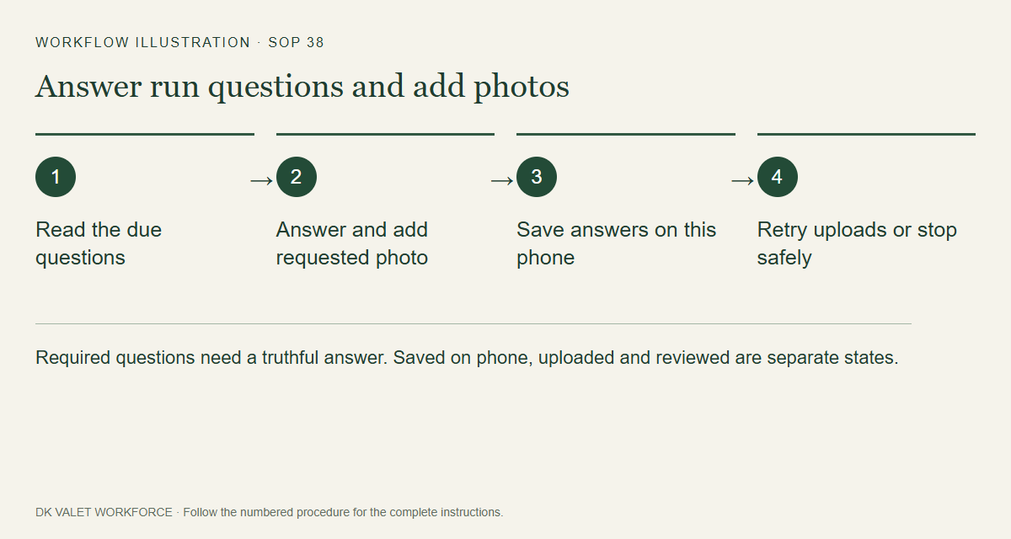
Step 2 · Required questions need a truthful answer. Saved on phone, uploaded and reviewed are separate states.
Workflow illustration. Follow the complete numbered instructions on the previous page.

  - SOP 39 | Associate work

Follow the route and report an issue
Perform the assigned work while checking recording health.
For Mobile · Associate
Before you start An authorized active run and the assigned unit list must be available.
Open Your route

Step 1 Review the route
Read the instructions and use the route map or Assigned units to understand the work.

Step 2 Work the assigned units
Walk the route normally with the phone carried consistently. Routine associate runs do not require scanning or tapping at every unit.

Step 3 Read evidence status
Watch supporting visit evidence, unresolved units, GPS accuracy and upload warnings. Those are evidence indicators, not proof that each unit was serviced.

Step 4 Report an issue
Use Report an issue and contact the supervisor shown. Describe blocked access, equipment problems or unresolved work.

Step 5 Finish when work ends
Select Finish route when done. If scheduled time has ended but the run is still active, complete closeout; the displayed separate safety cutoff still applies.

Step 6 Check your teammates
During a shared property run, orange pins show fresh coworker positions. Tap a T unit marker for attributed team evidence. Team confirmations do not silently increase your personal totals. Stopped or stale coworker positions disappear.
Check your result You reach route review with an accurate understanding of the work performed and any exceptions.
If something goes wrong If route or unit data is unavailable, refresh when connected and contact your supervisor. Do not claim all units were hit when unsure.
See the picture reference on the next page.

SOP 39 Picture reference
  - Follow the route and report an issue
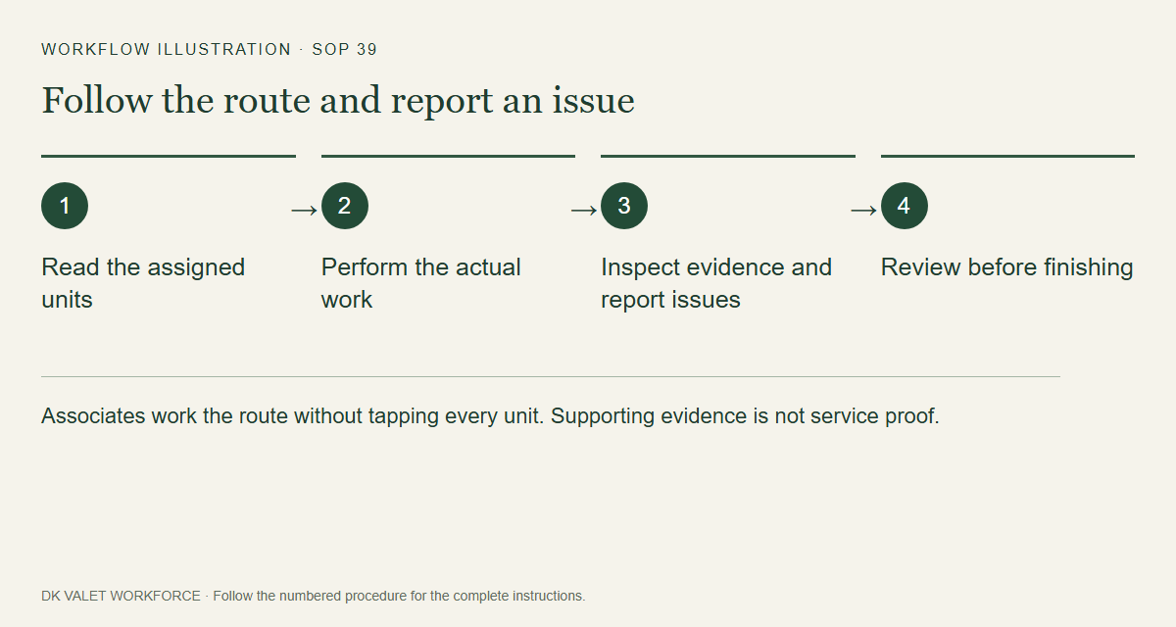
Step 2 · Associates work the route without tapping every unit. Supporting evidence is not service proof.
Workflow illustration. Follow the complete numbered instructions on the previous page.

  - SOP 40 | Associate work

Finish a route and confirm clock out
Stop collection and submit an accurate completion statement.
For Mobile · Associate
Before you start Review the actual work and unresolved units before confirming.
Open Your route > Finish route

Step 1 Review your route
Select Finish route. Complete the due clock-out questions and requested photos, then inspect Review your route and unresolved items. Questions are retained from when the clock-out step first opens.

Step 2 Choose the truthful statement
Use Confirm all units hit only if you can confirm it. Otherwise use Finish with exceptions and add the relevant note.

Step 3 Clock out and submit
Use Clock out and submit confirmation or Clock out with exceptions. Wait for the resulting stopped/finished state.

Step 4 Confirm the stop
If Collection is stopping remains, keep the phone online and use Retry clock-out confirmation.

Step 5 Confirm the upload
On Route finished, check collection stop separately from the statement, answers and photo uploads. Reconnect and use the displayed retry for pending evidence. Uploaded photos may still await manual supervisor review.
Check your result Clock-out is recorded, collection is stopped and the finish statement is confirmed or explicitly marked pending.
If something goes wrong Use the stop-with-exception action if questions or camera fail. If phone collection stop needs attention, turn off location permission and contact the supervisor. Never clear pending app data to retry.
See the picture reference on the next page.

SOP 40 Picture reference
  - Finish a route and confirm clock out
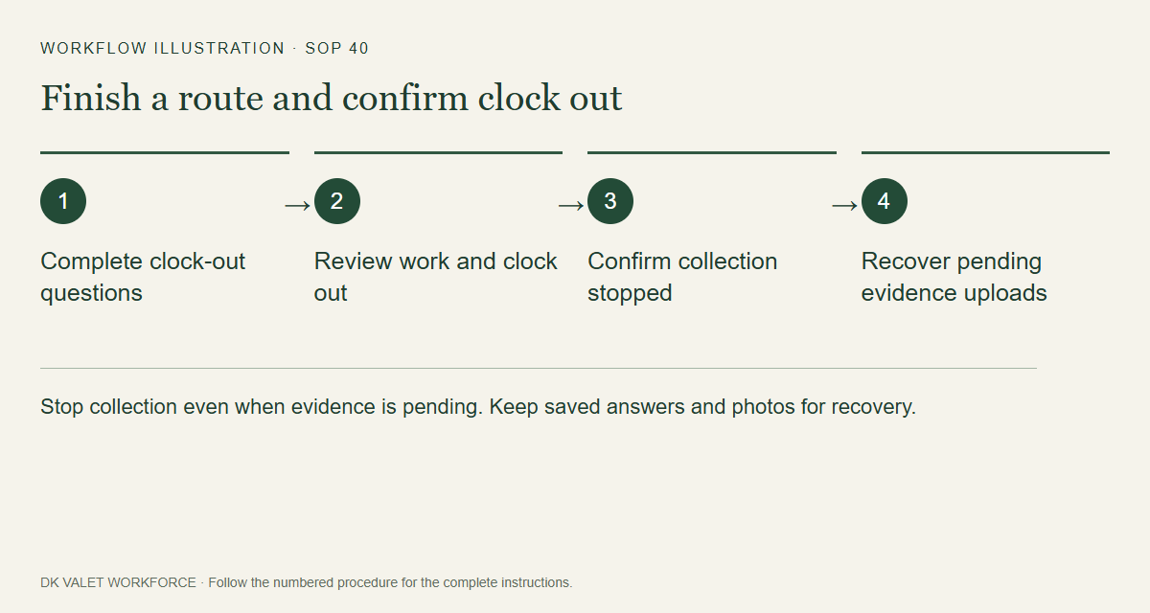
Step 2 · Stop collection even when evidence is pending. Keep saved answers and photos for recovery.
Workflow illustration. Follow the complete numbered instructions on the previous page.

  - SOP 41 | Associate work

Recover from offline or tracking problems
Protect pending work and resolve recording or upload failures.
For Mobile · Associate / Supervisor
Before you start Stay with the same device and signed-in account holding the pending evidence.
Open Active run or setup > Status

Step 1 Read the exact warning
Distinguish permission failure, stale or inaccurate location, interrupted collection, camera/storage trouble and pending answers or photo uploads. Record the property, run and warning.

Step 2 Restore the required condition
Reconnect to the network for upload problems. Check location permission and services for recording problems. Return to the active task after changes.

Step 3 Use the existing recovery action
Use the displayed recovery action for the same run. Saved question steps, answers and photos can upload after clock-out or expiration; reopening the app must not create a new answer merely to retry.

Step 4 Verify stop and upload separately
Read collection status separately from answer, photo, route and finish uploads. Saved on phone, uploaded and supervisor-reviewed are different results. An unresolved upload does not authorize off-shift collection.

Step 5 Escalate unresolved problems
Contact your supervisor with the message and approximate time. Keep the app’s pending records; do not uninstall or clear storage as a retry method.
Check your result The app either confirms recovery or shows a specific remaining issue for supervisor follow-up.
If something goes wrong An emergency cutoff limits authorization even while offline. Restoring connectivity does not authorize collecting new off-shift location.
See the picture reference on the next page.

SOP 41 Picture reference
  - Recover from offline or tracking problems
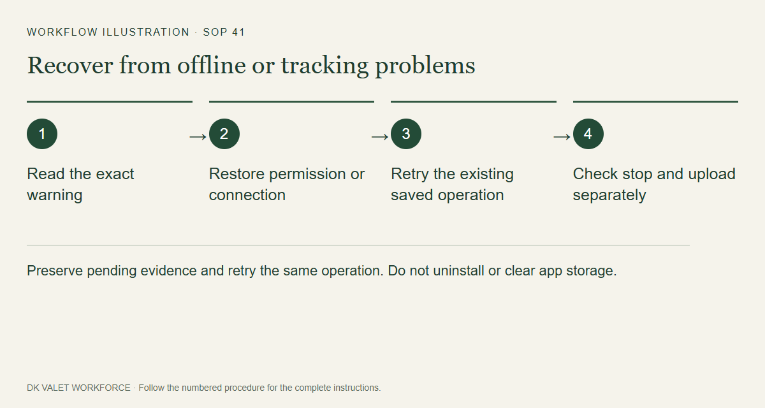
Step 2 · Preserve pending evidence and retry the same operation. Do not uninstall or clear app storage.
Workflow illustration. Follow the complete numbered instructions on the previous page.

  - SOP 42 | Advanced administration

Use tracking safety and emergency controls
Record an authorized effective-dated property tracking control.
For Web and mobile · Administrator / Supervisor
Before you start Verify the exact property and operational reason. These controls affect tracking authorization.
Open Account > Tracking safety & emergency stops

Step 1 Select the property
Open Tracking safety or Remote tracking control and verify the property header.

Step 2 Choose the control
Select the intended enable/disable state. Read the effective start and optional end fields; web control times are explicitly UTC.

Step 3 Record the reason and save
Enter Operational reason and use Record tracking control. Verify the saved history and effective interval.

Step 4 Follow up on device state
Devices stop when they receive the control. Check the affected run and contact the worker if a phone remains offline or local stop needs attention.
Check your result Control history shows the intended version and interval; the server rejects post-cutoff collection.
If something goes wrong An offline phone may not receive a remote instruction immediately. Re-enabling tracking does not bypass assignments, policy or a session cutoff.
See the picture reference on the next page.

SOP 42 Picture reference
  - Use tracking safety and emergency controls
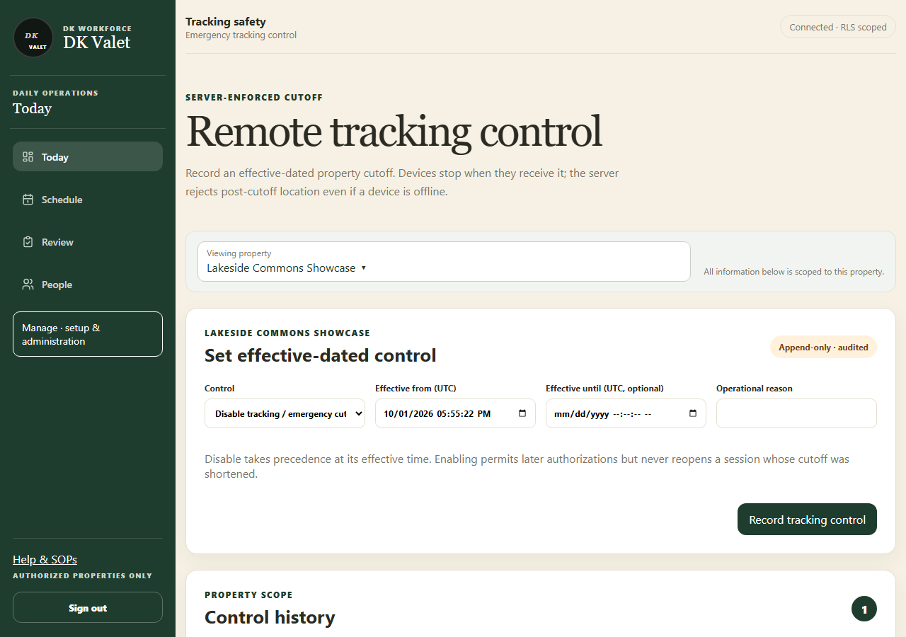
Step 2 · Remote tracking control: use the property selector and the task controls shown.
Application screenshot with training data.

  - SOP 43 | Advanced administration

Inspect processing health and retry a failed job
Find processing failures and retry only after reviewing the issue.
For Web and mobile · Administrator / Supervisor
Before you start Support access is required. Associate uploads may need to arrive before analysis can finish.
Open Manage > Operational support

Step 1 Open processing health
Choose Manage and View processing health, or Operational support on mobile. Select the authorized property scope.

Step 2 Inspect the job
Read queue status, failure information and the associated session. Check device diagnostics and push delivery information when relevant.

Step 3 Review an eligible retry
For a job needing attention, select Review retry and investigate repeated failures before retrying.

Step 4 Queue and verify
Enter Reason for retry and select Queue this retry. Refresh the queue and later inspect the run’s analysis result.
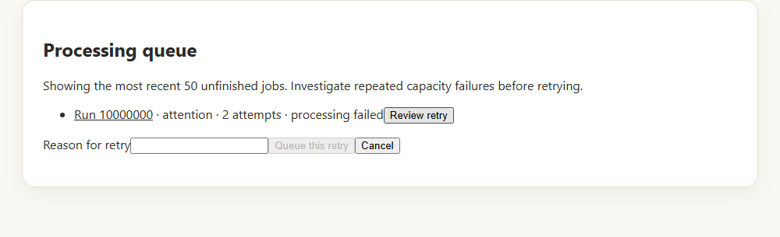
Review an unfinished job and give a reason before queueing its retry. Application component preview with training data.
Check your result The job shows its new queue state or a completed analysis result.
If something goes wrong Repeated capacity or processing failures need an administrator’s investigation. Repeated retries alone are not a repair.

  - SOP 44 | Advanced administration

Manage approved data collection and timing policies
Review effective settings and apply an approved policy to future work.
For Web · Administrator
Before you start Administrator access and approval for the intended collection configuration are required. This guide does not authorize a new pilot.
Open Manage > Data collection admin

Step 1 Choose the scope
Open Data collection and select the intended organization/property. Read inherited defaults and current property overrides.

Step 2 Review the relevant section
Choose routine tracking, setup sensors, associate route evidence, collection defaults or run timing as appropriate. Read the displayed effective settings.

Step 3 Enter approved values
Set only the approved values, notice version and reason. For timing, review early-start behavior and the separate maximum run duration.

Step 4 Confirm futurerun changes
Review the form’s confirmation checkbox or review step and publish using the named policy action.

Step 5 Verify the effective version
Refresh and confirm the new version and scope. Existing sessions keep their authorized snapshot and emergency cutoff.
Check your result The intended future-run policy is recorded with its reason and effective version.
If something goes wrong Technical settings do not themselves approve employee notice, retention, experimental pilots or employment consequences.
See the picture reference on the next page.

SOP 44 Picture reference
  - Manage approved data collection and timing policies
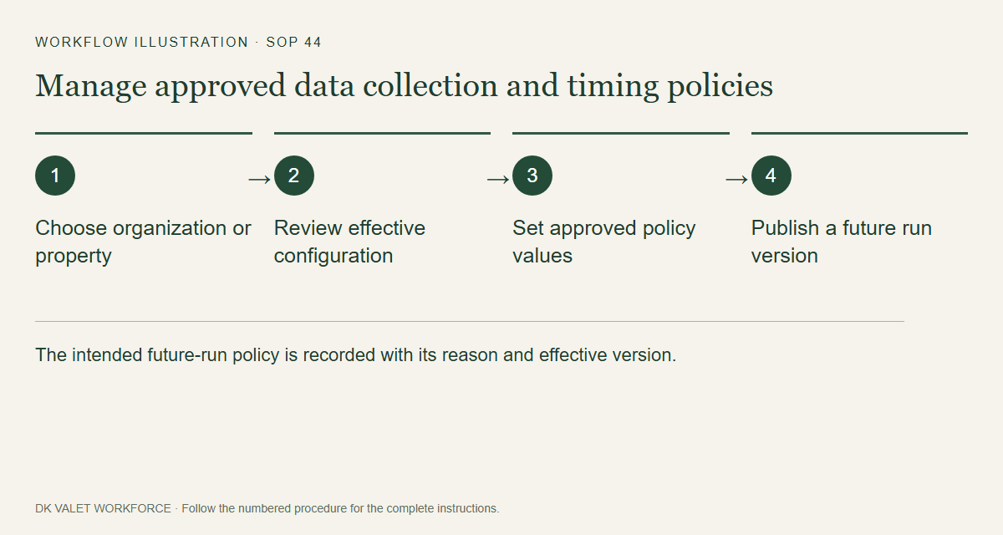
Step 2 · The intended future-run policy is recorded with its reason and effective version.
Workflow illustration. Follow the complete numbered instructions on the previous page.

  - SOP 45 | Advanced administration

Read device and tracking insights
Inspect aggregate quality patterns without overinterpreting small cohorts.
For Web · Administrator
Before you start Authorized insight access is required.
Open Manage > Device & research tools

Step 1 Open the insight screen
Select Device & tracking insights from authorized administration tools.

Step 2 Set the available filters
Choose property and the available device, platform or time filters. Read the cohort counts.

Step 3 Interpret the quality measures
Compare accuracy, freshness, permission, sync and device dimensions together. Respect suppressed or unknown results.

Step 4 Investigate a supported issue
Use an authorized run review or Operational support for a concrete failure. Preserve the distinction between device quality and employee performance.
Check your result You can describe the supported quality pattern and any limitations of the cohort.
If something goes wrong Small cohorts may be withheld. Missing or degraded evidence cannot be converted into an exact indoor visit claim.
See the picture reference on the next page.

SOP 45 Picture reference
  - Read device and tracking insights
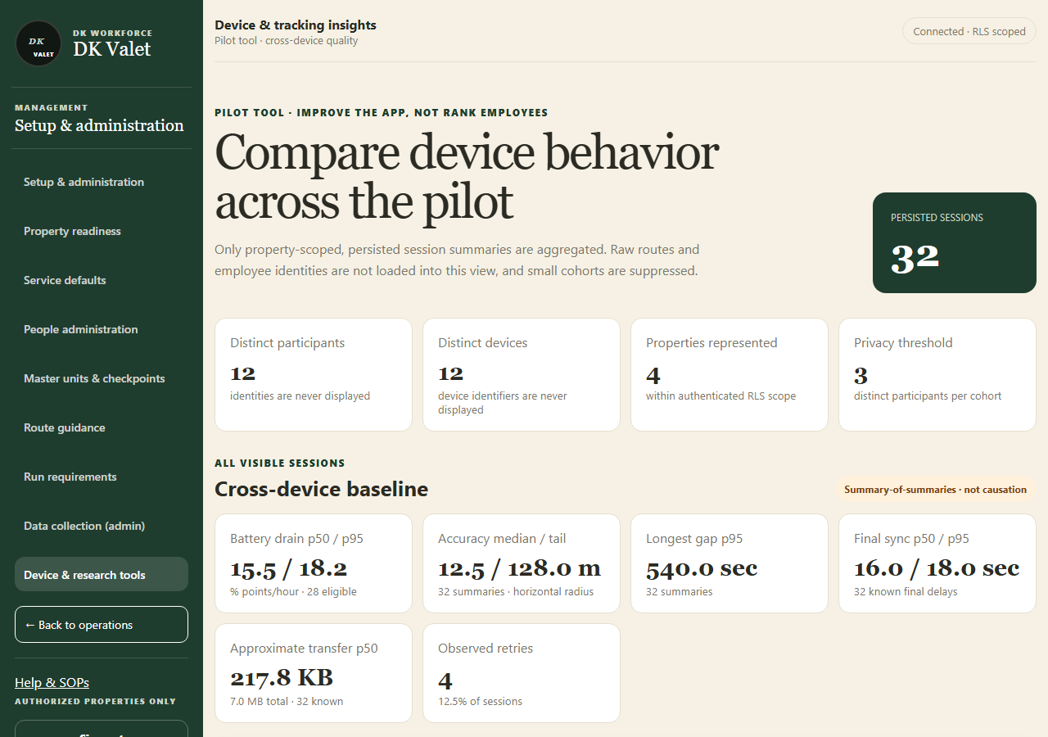
Step 2 · Compare device behavior across the pilot: use the property selector and the task controls shown.
Application screenshot with training data.

  - SOP 46 | Advanced administration

Use the setup research workbench
Compare existing recorded evidence using the available research tools.
For Web · Administrator / Supervisor
Before you start Use only an authorized research workflow. Experiments are separate from route publication.
Open Completed setup run > Research workbench

Step 1 Open the source recording
Choose the correct property and completed setup run, then open Research workbench when available.

Step 2 Select the comparison
Read the available model, replay and analysis options. Keep the recorded run and comparison settings identifiable.

Step 3 Run and inspect the result
Use the offered comparison action and wait for results. Inspect raw coverage, marked units, path gaps and uncertainty together.

Step 4 Keep the interpretation qualified
Record observations for the authorized study. Publish operational references only through the separate reviewed master and associate-route workflows.
Check your result The result is tied to a known recording and comparison configuration.
If something goes wrong A research path is an estimate. This screen does not authorize new collection or automatically change the operational master.
See the picture reference on the next page.

SOP 46 Picture reference
  - Use the setup research workbench
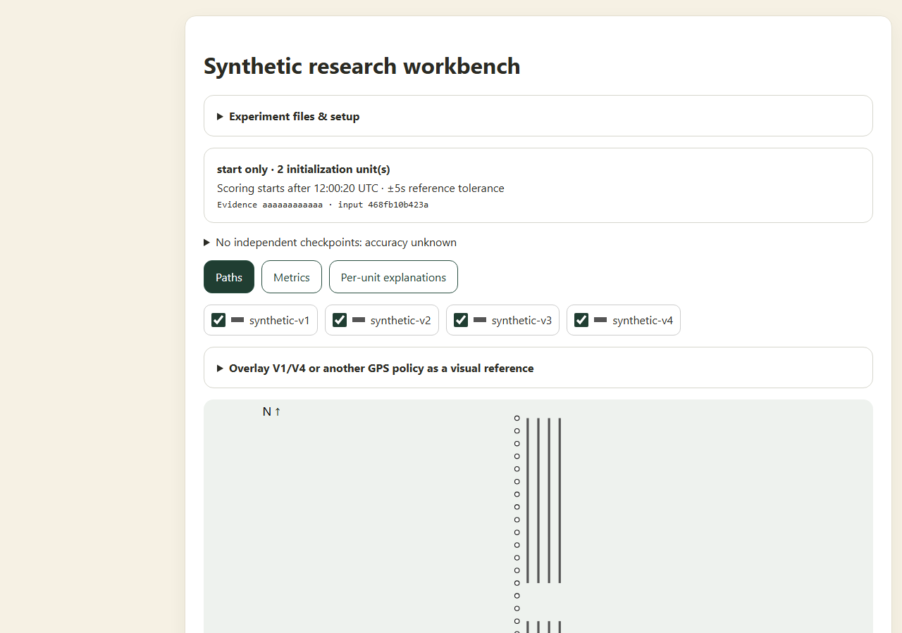
Step 2 · Compare retained setup evidence in the research workbench; model paths remain estimates.
Application component preview with training data. Native permission prompts may differ.

  - SOP 47 | Advanced administration

Perform an authorized guided movement test
Follow the existing measured walking/stopping test sequence and inspect local results.
For Mobile · Administrator / Supervisor
Before you start An authorized setup session, supported build and safe measured test area are required. Use only an approved field study.
Open Property setup > Movement tests or Saved tests

Step 1 Open Movement tests
In property setup select Movement tests. Prepare the specified straight or square course and review the recording mode.

Step 2 Start and follow the prompts
Pass start checks and start test recording. Follow each on-screen trial’s walking, turning or stopping instructions and enter actual observations when requested.

Step 3 Finish the recording
Complete the prescribed trials and finish the authorized setup recording. Check pending uploads and save status.

Step 4 Inspect Saved tests
Open Saved tests on the same phone, select the recording and review the preserved trials and comparisons.
Check your result The local saved test retains its original trials and comparison results.
If something goes wrong These tests do not prove exact indoor location and do not replace operational setup or route publication.
See the picture reference on the next page.

SOP 47 Picture reference
  - Perform an authorized guided movement test
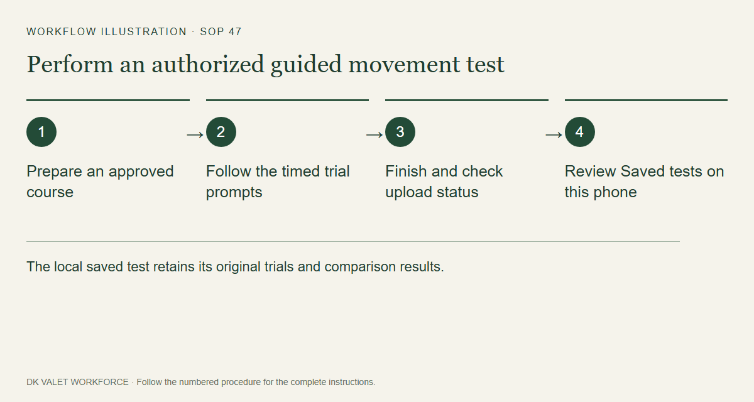
Step 2 · The local saved test retains its original trials and comparison results.
Workflow illustration. Follow the complete numbered instructions on the previous page.

  - SOP 48 | Advanced administration

Find missing setup history and request an archive review
Understand why an earlier setup may be hidden and request an authorized history review.
For Web and mobile · Administrator / Supervisor
Before you start Have the property and approximate recording date. There is no end-user archive or restore button in this version.
Open Property readiness > Setup history

Step 1 Refresh the property history
Open the correct property’s setup history and refresh or reopen it. Confirm that you are looking at the intended property.

Step 2 Check retained references
An archived walk may be hidden from ordinary history while a published master still refers to it. Use an authorized source-evidence link from the retained reference when offered.

Step 3 Request an administrator review
Send the responsible administrator the property, recording date and reason for reviewing hidden history. Archive or restore requires a separately approved operator maintenance action.

Step 4 Verify after the approved change
After the administrator confirms a change, refresh history and verify the intended visibility. Raw observations and published references are retained.
Check your result The missing history is explained or the approved visibility change appears after refresh.
If something goes wrong Do not try to delete a property or change its current master to clear history. Ask the administrator to investigate the specific recording.
See the picture reference on the next page.

SOP 48 Picture reference
  - Find missing setup history and request an archive review
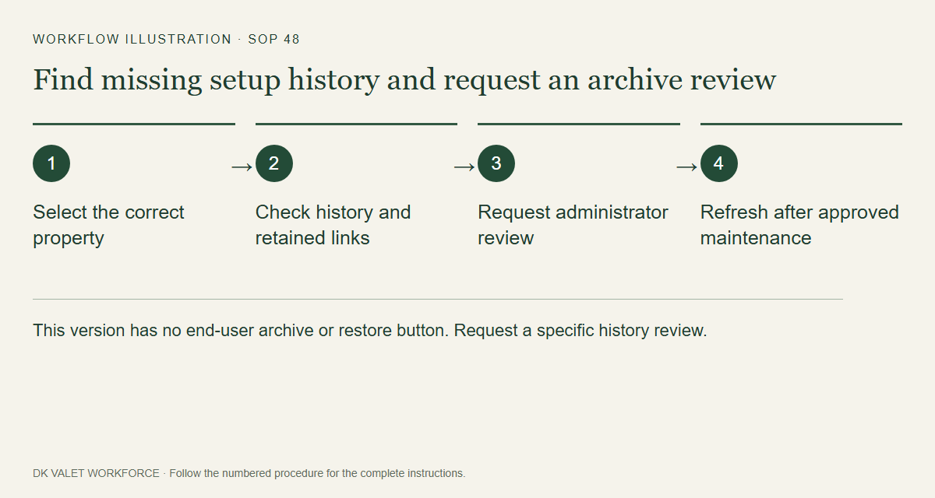
Step 2 · This version has no end-user archive or restore button. Request a specific history review.
Workflow illustration. Follow the complete numbered instructions on the previous page.

  - SOP 49 | Getting started

Sign out and review privacy information
End your account session and find the application’s privacy and terms information.
For Web and mobile · Administrator / Supervisor / Associate
Before you start Complete active run/setup closeout and preserve pending uploads first.
Open Account > Sign out and website footer

Step 1 Check current work
Confirm any route or setup recording is finished. Read pending stop, upload and finish-statement messages before changing accounts.

Step 2 Open Account
On mobile open Account & help. On web use Account or the sidebar Sign out control.

Step 3 Sign out
Select Sign out and follow any pending-work warning. If sign-out is blocked, complete the indicated recovery or contact your supervisor.

Step 4 Read the published notices
On the Operations website use Privacy and Terms in the footer. Use Help & SOPs to return to these procedures.
Check your result The app returns to sign-in when sign-out is permitted; pending-work warnings have been addressed.
If something goes wrong Signing out is not a substitute for confirming collection has stopped.
See the picture reference on the next page.

SOP 49 Picture reference
  - Sign out and review privacy information
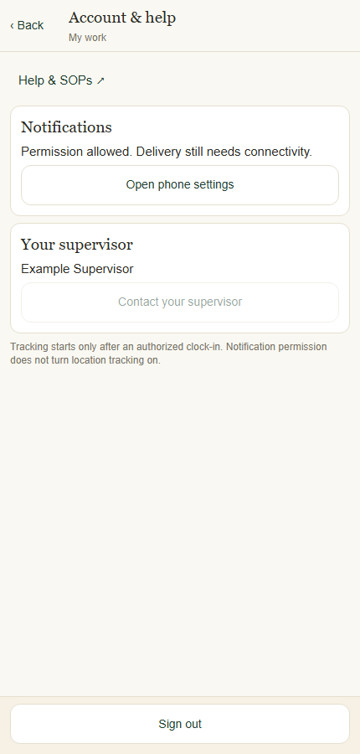
Step 2 · Account and help contains support, notification settings and Sign out.
Application component preview with training data. Native permission prompts may differ.

  - SOP 50 | Scheduling

Build copy or bulk edit shifts
Review a multi-shift change before applying the batch.
For Web · Administrator / Supervisor
Before you start Verify the selected properties, dates and eligible workers. A batch is limited to 100 operations.
Open Schedule > Property schedule > Portfolio schedule

Step 1 Open the batch tools
Open Property schedule from Schedule, then expand Build shifts across properties to use the Bulk schedule composer.

Step 2 Build or reuse the draft
Choose properties, service dates and eligible employees per property. Set Starts locally, Ends locally, notes and reason. Optionally load a device template or use Copy previous week, then inspect every copied date.

Step 3 Review and apply
Select Review batch. Read every operation and warning, then Apply reviewed batch only when the full batch is correct.

Step 4 Bulk edit existing shifts
Select eligible shifts in the portfolio schedule. In Bulk shift action choose Move or reassign or Cancel selected shifts. Set the change and required reason, then Review selected changes and Apply reviewed batch.

Step 5 Verify the result
Inspect the saved shifts and pending acceptance. Save device template stores a reusable draft on this browser; it is not a published schedule or shared server template.
Check your result The reviewed batch is applied together and the calendar shows the intended dated shifts.
If something goes wrong Clear selections and refresh if a shift has changed or started. Access/training restrictions still apply even when overlap warnings are advisory.
See the picture reference on the next page.

SOP 50 Picture reference
  - Build copy or bulk edit shifts
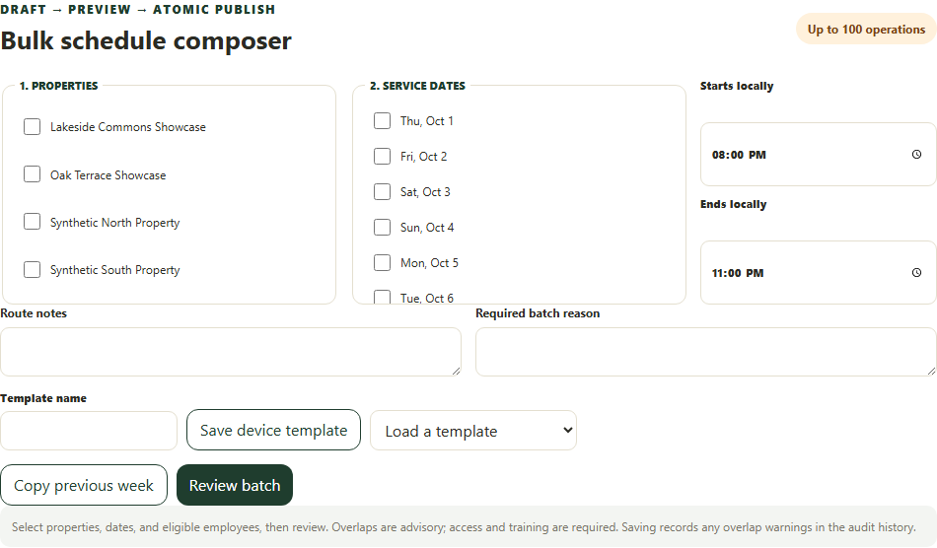
Step 2 · Choose properties, dates and employees, then review the complete batch.
Application screenshot with training data.

  - SOP 51 | Advanced administration

Set an effective staffing target
Record a property staffing target from an approved effective date.
For Web · Administrator
Before you start Property-administrator permission is required. Distinguish this target from the people needed in each recurring service window.
Open Property schedule > Set staffing target

Step 1 Open the target form
Open the portfolio/property schedule tools and locate Set staffing target.

Step 2 Choose property and headcount
Select Property and enter Required headcount. Confirm the target is for the selected property.

Step 3 Set the effective time and reason
Enter Effective from (property time) and the approved Reason. Check the property time zone.

Step 4 Save and verify
Select Save effective target, wait for confirmation and inspect the staffing summary after refresh.
Check your result A new effective target is recorded; it does not itself assign any worker.
If something goes wrong Use Service defaults to change individual recurring window requirements and Schedule to assign workers.
See the picture reference on the next page.

SOP 51 Picture reference
  - Set an effective staffing target
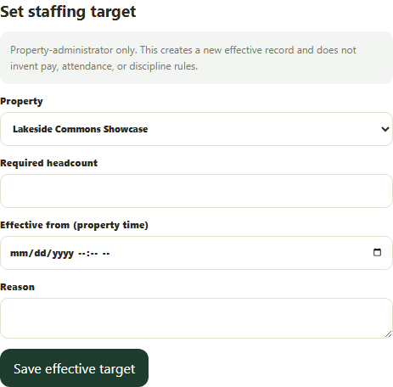
Step 3 · Set an effective property-local staffing target with a reason.
Application screenshot with training data.

  - SOP 52 | Daily operations

Export the operations view
Export the loaded reporting period for selected authorized properties.
For Web · Administrator / Supervisor
Before you start Verify selected properties and the loaded reporting period. Calendar day, status and text filters do not narrow this export.
Open Portfolio operations > Export operations CSV

Step 1 Choose the properties
Open Property schedule and select the intended properties in the portfolio operations filter. Confirm the authorized scope.

Step 2 Check the reporting period
The export uses the full reporting period loaded by this page. Calendar date, Day/Week view, shift status and text search affect the screen but do not narrow the exported dataset.

Step 3 Export
Select Export operations CSV beside the saved-view controls. Wait for the download or read the export failure message.

Step 4 Verify the downloaded rows
Open the CSV and check property and date values. Filter the file to the required dates if necessary. Share workforce information only with authorized recipients and preserve unknown and degraded labels.
Export operations CSV uses the selected properties and full loaded reporting period. Application screenshot with training data.
Check your result The CSV contains the selected properties across the loaded reporting period.
If something goes wrong If the export fails, refresh the view and retry. Do not broaden the property scope to work around an access failure.

  - SOP 53 | Property setup

Publish property and global notes
Publish temporary or newcomer instructions to the properties you manage.
For Web and mobile · Administrator / Supervisor
Before you start Prepare a short message without private credentials. Global means the explicitly selected properties, not future properties.
Open Manage > Property and global notes

Step 1 Choose the target and message
Select one property or All properties I manage. Enter the message and choose setup, associate runs or both.

Step 2 Set audience and expiration
Choose Everyone or New to this property. Newcomer notes appear before the first routine clock-in and for the configured number of days afterward. An optional expiration ends that date in your device time zone.

Step 3 Review and publish
Check the explicit target count, message, audience and expiration, then publish. The message appears in applicable pre-start instructions; it does not send a push notification.

Step 4 Withdraw when no longer needed
Open the note at the relevant property and withdraw it. The history is retained. Global publication creates a separate scoped record for each target.
Check your result The note appears at the intended properties with its audience and expiration.
If something goes wrong If publication is uncertain, refresh before retrying. Use direct contact for urgent safety issues.
See the picture reference on the next page.

SOP 53 Picture reference
  - Publish property and global notes
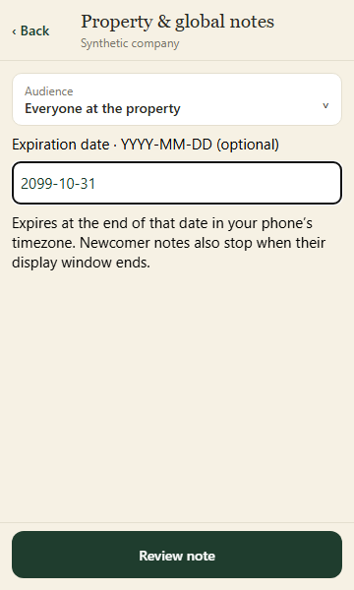
Step 2 · Choose who sees the note and its optional expiration. Review the explicit property target before publishing.
Application component preview with training data. Native permission prompts may differ.

  - SOP 54 | Property setup

Configure building and floor numbering
Decode consistent door labels for future setup marks without treating GPS as floor evidence.
For Web and mobile · Administrator / Supervisor
Before you start Know the actual property numbering convention. Earlier observations are not changed.
Open Manage > Property > Unit numbering or floor rule

Step 1 Open the selected property
On web open Service settings, then Unit numbering. On mobile select the property in Manage, then Unit numbering or floor rule.

Step 2 Describe the label
Use one B, F or U per character for building, floor and unit groups. BFUU decodes 1324 as building 1, floor 3, unit 24. Use the floor offset only when the actual convention requires it.

Step 3 Test a real example
Enter a representative label in the preview. Check every decoded field. Nonmatching labels remain unknown; explicit building and floor entries override decoding.

Step 4 Save for future marks
Enter a reason and save. A blank pattern disables future decoding. The rule version and original request are retained; changing rules does not rewrite historical evidence.
Check your result The preview matches the numbering convention and the saved rule applies to future marks.
If something goes wrong If the existing rule cannot be loaded, refresh before saving. Do not guess a rule for inconsistent labels.
See the picture reference on the next page.

SOP 54 Picture reference
  - Configure building and floor numbering
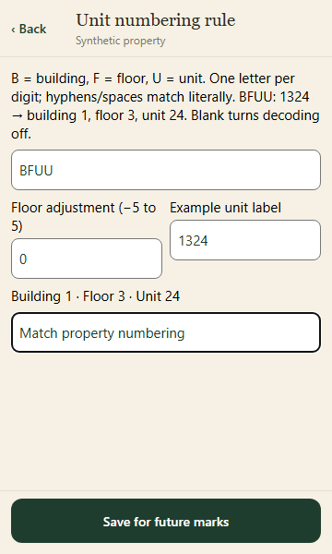
Step 3 · Preview the actual label convention before saving a rule for future setup marks.
Application component preview with training data. Native permission prompts may differ.

  - SOP 55 | Daily operations

Start a supervisor support run
Record work at an assigned property outside a normal scheduled window.
For Mobile · Administrator / Supervisor
Before you start An active field-property assignment, published route, configured run-duration policy and usable location are required.
Open Today > Clock in at a property

Step 1 Choose the property
Select Clock in at a property from Today. Search and choose the property where you will actually work. Preparation alone does not collect location.

Step 2 Complete arrival checks
Review applicable instructions and permissions. Be inside the configured boundary. The supervisor timing exception does not bypass geofence or device checks.

Step 3 Clock in and answer run questions
Clock in only when ready to work. Answer the due questions truthfully and add requested photos (SOP 38), then follow the published unit route.

Step 4 Finish and verify
Use Finish run when work ends. Review unconfirmed units and submit your truthful statement. Confirm collection stopped and evidence uploaded separately. The independent safety cutoff remains active.
Check your result An authorized support run appears for the chosen property and is closed out when work ends.
If something goes wrong If multiple phase routes exist without a property-wide route, use an explicitly scheduled phase shift. Ask an administrator to resolve missing configuration.
See the picture reference on the next page.

SOP 55 Picture reference
  - Start a supervisor support run
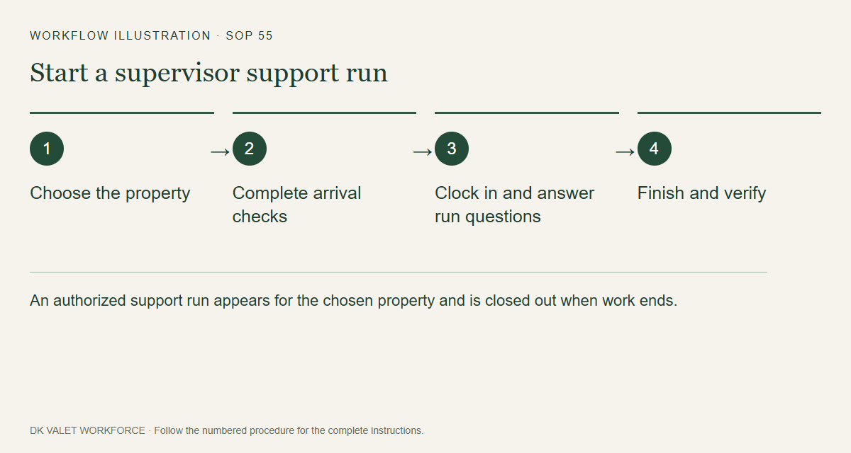
Step 2 · An authorized support run appears for the chosen property and is closed out when work ends.
Workflow illustration. Follow the complete numbered instructions on the previous page.

